**Requirements Document**

|  |  |
| --- | --- |
| Course | CIS 4911 |
| System | (IBM) Track and keep score of and compute a group's sustainability efforts |
| Team | Jorge McGarry  Monica Del Prado |
| Due Date | 12-10-2014 |
| Instructor | Masoud Sadjadi |
| Mentor | Juan Caraballo |

Table of Contents

Overview 3

1. Introduction 4

1.1 Problem Definition. 4

1.2 Scope of system 4

1.3 Terminology - Definitions, acronyms, and abbreviations. 4

1.4 Overview of document 5

2. Current System 6

3. Project Plan 7

3.1 Project organization 7

3.2 Work breakdown 7

3.3 Cost Estimate 7

4. Proposed System Requirements 8

4.1 Functional Requirements – describes high-level functionality 8

4.2 Analysis of System Requirements 11

4.2.1 User Scenarios 11

4.2.2 Use case model 15

4.2.3 Static model 16

4.2.4 Dynamic model 17

5. Glossary 18

6. Appendix 19

6.1 Appendix A - Complete use cases 19

6.2 Appendix B - Use case diagram using UML 31

6.3 Appendix C - Static UML diagram 32

6.4 Appendix D - Dynamic UML diagrams 33

6.5 Appendix E - User Interface designs. 39

6.6 Appendix F - Diary of meeting and tasks. 39

7. References 43

# Overview

The main goal of the project is to develop a software application that entices people to recycle and keeps track of their efforts. The application will also have a “competitive spirit” built in, which means that recycling efforts will be compared against other registered users and groups. Users who excel in recycling will be provided some sort of reward in order to entice them in continuing the recycling behavior.

# Introduction

The Introduction provides a description about the system that will be built and the need of building such system. It will also provide a description of the expectations about the main system functionalities. Finally, it will provide a brief description of the rest of the document.

## Problem Definition.

Currently, there is no software application that tracks and compares people’s recycling efforts. We want to build an application that tracks recycling efforts and encourages people to use it by providing a competitive approach.

Since recycling and keeping track are completely voluntary we also want to build in some sort of reward aspect into the application, to entice people to keep track of their efforts.

## Scope of system

The system will allow companies, colleges, communities and any group of persons to keep track of their recycling efforts. The system will validate, track and reward recycling initiatives. The system will be available for personal use. The system will have a competitive aspect, which will encourage the use of the application.

Additionally, the system will encourage its use by providing a redemption dollar value to the recycling efforts, which are based on current Container Deposit Legislation.

## Terminology - Definitions, acronyms, and abbreviations.

|  |  |
| --- | --- |
| **Term** | **Definition** |
| Guest User | A user that has not created an account in the system |
| Registered User | A user that has created an account in the system |
| Group Owner | A user that created a group is automatically that group’s owner |
| Group Member | A registered user that joined a group. |

## Overview of document

Section 2 goes over what is currently being done in terms of recycling efforts. Since there is no real software behind recycling efforts done by individuals, the manual process being done will be explained.

Section 3 details the organization of the project including the roles of team members.

Section 4 specifies functional and non-functional requirements and creates use cases to describe the interactions between actor(s) and system.

In Section 5 is the glossary of terms used in the document, with an emphasis on domain specific terms.

Section 6 is the appendix. This section contains the scenarios and use case diagrams (both for functional and non-functional requirements). Also in this section detailed sequence and class diagrams are included. The document ends with a diary of meeting and tasks.

Section 7 will list references used.

# Current System

There is no current system currently in place that we are revising.

# Project Plan

The project plan was created using the Agile way. The project plan assumes we would be doing two week sprints. Based on the requirements, we developed user stories of which the team selected which stories to work on, on any given sprint.

## Project organization

Monica Del Prado will work on the user interface and game related aspects of the application.

Jorge McGarry will work on the platform, backend and administration portions of the website.

Both Jorge McGarry and Monica Del Prado will work on the documentation in relations to the work they are doing.

## Work breakdown

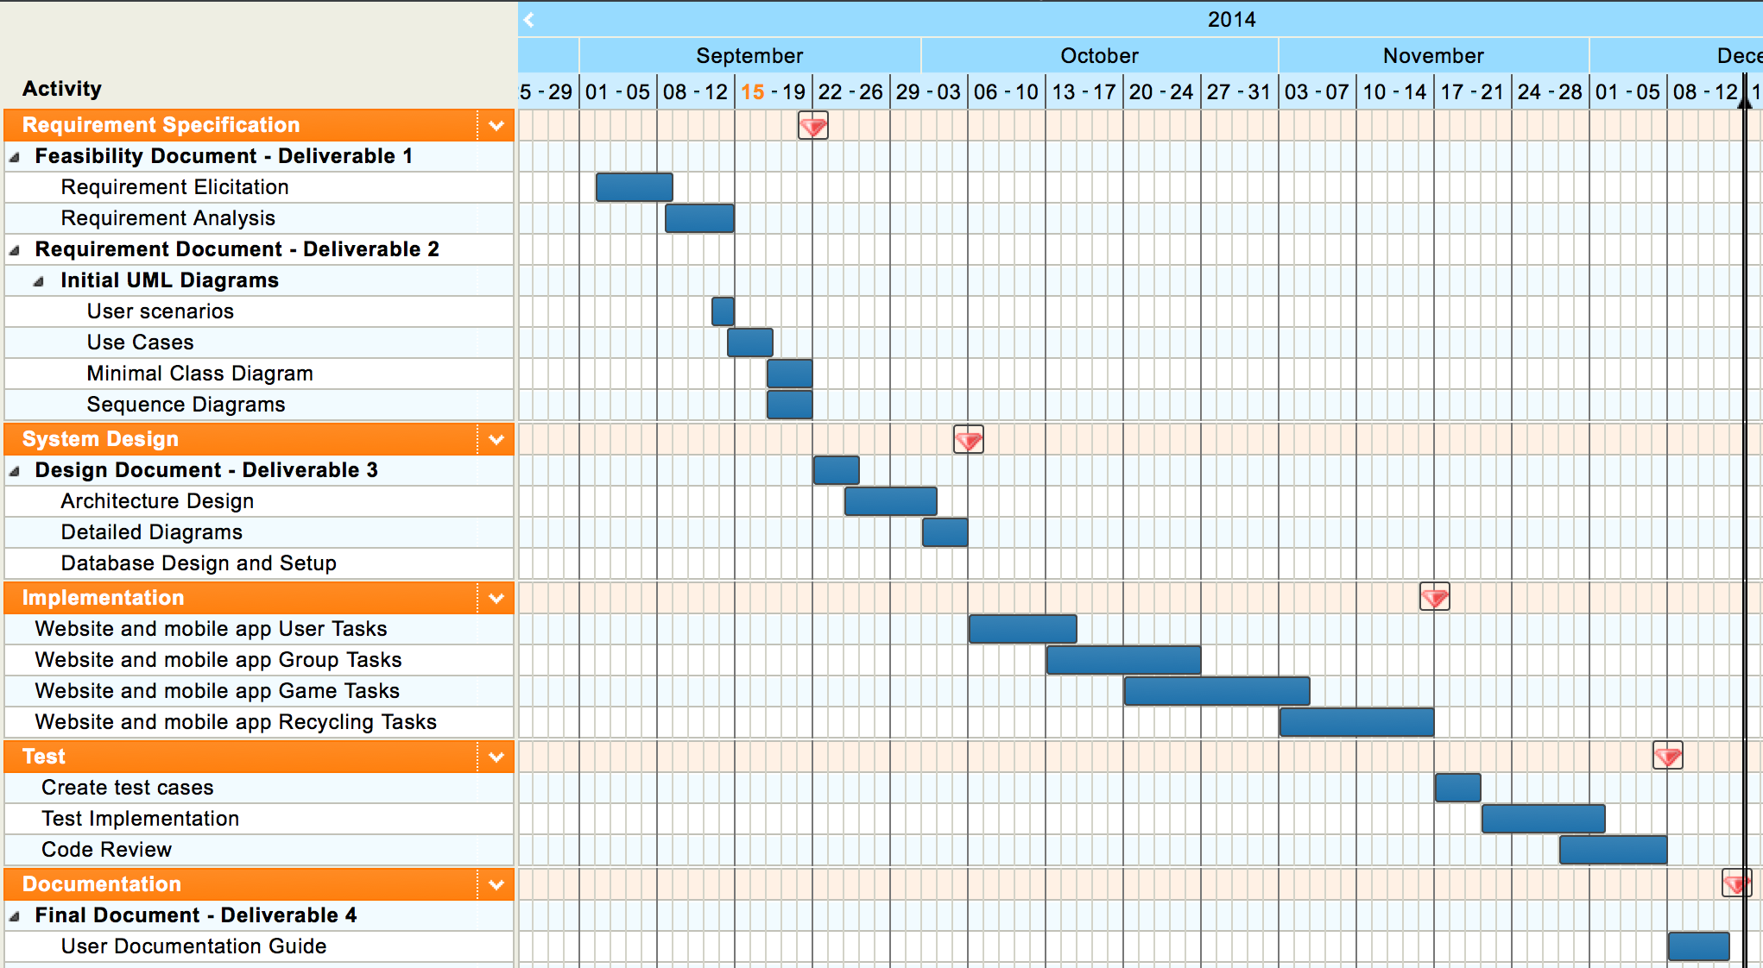

Figure 3.2.1- Project schedule

## Cost Estimate

No costs will be associated to this project.

Personal computers will be used for the development and open source software

# Proposed System Requirements

The following section provides information about the functional and non-functional requirements of the proposed system. These requirements were analyzed to create the non-functional requests with regards to: usability, reliability, performance, and supportability.

## Functional Requirements

* **Allow user to register**
* Usability: The register form is simple and easy to follow.
* Reliability: The system should perform correctly 99% of the time.
* Performance: The system should respond within 1 seconds.
* Supportability: The system should be easy to maintain
* **Allow users to edit their profile**
* Usability: Data displayed should be easy to follow. Each user can see only their profile.
* Reliability: The system should perform correctly 99% of the time.
* Performance: The system should respond within 1 second.
* Supportability: The system should be easy to maintain.
* **Allow users to view recycling locations in a map**
* Usability: The interface should be simple.
* Reliability: The system should perform correctly 99% of the time.
* Performance: The system should respond within 1 second.
* Supportability: The system should be easy to maintain.
* **Allow users to create groups**
* Usability: Any user should be able to create a group.
* Reliability: The system should perform correctly 99% of the time.
* Performance: The system should respond within 2 seconds.
* Supportability: The system should be easy to maintain.
* **Allow users to edit group information**
* Usability: The edit form is simple and easy to follow.
* Reliability: The system should perform correctly 99% of the time.
* Performance: The system should respond within 1-5 seconds, depending on the file size.
* Supportability: The system should be easy to maintain.
* **Allow users to view the groups they have joined**
* Usability: Users are presented with a simple interface.
* Reliability: The system should perform correctly 99% of the time.
* Performance: The system should respond within 1 second.
* Supportability: The system should be easy to maintain.
* **Allow users to search groups to join**
* Usability: Users are presented with a simple interface.
* Reliability: The system should perform correctly 99% of the time.
* Performance: The system should respond within 1 second.
* Supportability: The system should be easy to maintain.
* **Allow users to join groups**
* Usability: Users are presented with a simple interface.
* Reliability: The system should perform correctly 99% of the time.
* Performance: The system should respond within 1 second.
* Supportability: The system should be easy to maintain.
* **Allow groups owners to reject requests**
* Usability: Group owners are presented with a simple interface.
* Reliability: The system should perform correctly 99% of the time.
* Performance: The system should respond within 1 second.
* Supportability: The system should be easy to maintain.
* **Allow groups owners to accept requests**
* Usability: Group owners are presented with a simple interface.
* Reliability: The system should perform correctly 99% of the time.
* Performance: The system should respond within 1 second.
* Supportability: The system should be easy to maintain.
* **Allow users to recycle items**
* Usability: Recycling item form is easy to follow.
* Reliability: The system should perform correctly 99% of the time.
* Performance: The system should respond within 1 second.
* Supportability: The system should be easy to maintain.
* **Allow users to view group activity**
* Usability: Group activity is presented in tabular or graphical interface.
* Reliability: The system should perform correctly 99% of the time.
* Performance: The system should respond within 3 seconds.
* Supportability: The system should be easy to maintain.
* **Allow site admin to create materials**
* Usability: Site admin is presented with material creation form. The data is validated to ensure consistency in the system.
* Reliability: The system should perform correctly 99% of the time.
* Performance: The system should respond within 1 second. It should take less than 1 minute to complete.
* Supportability: The system should be easy to maintain.
* **Allow site admin to create items**
* Usability: Site admin is presented with item creation form. The data is validated to ensure consistency in the system.
* Reliability: The system should perform correctly 99% of the time.
* Performance: The system should respond within 1 second. It should take less than 1 minute to complete.
* Supportability: The system should be easy to maintain.
* **Allow Contest admin to create contests**
* Usability: Contest admin is presented with contest creation form.
* Reliability: The system should perform correctly 99% of the time.
* Performance: The system should respond within 1 second. It should take less than 1 minute to complete.
* Supportability: The system should be easy to maintain.
* **Allow to view contests in the system**
* Usability: Users are presented with a simple interface.
* Reliability: The system should perform correctly 99% of the time.
* Performance: The system should respond within 1 second.
* Supportability: The system should be easy to maintain.
* **Allow to view materials in the system**
* Usability: Users are presented with a simple interface.
* Reliability: The system should perform correctly 99% of the time.
* Performance: The system should respond within 1 second.
* Supportability: The system should be easy to maintain.
* **Allow to view items in the system**
* Usability: Users are presented with a simple interface.
* Reliability: The system should perform correctly 99% of the time.
* Performance: The system should respond within 1 second.
* Supportability: The system should be easy to maintain.
* **Allow to search groups in the system**
* Usability: Users are presented with a simple interface.
* Reliability: The system should perform correctly 99% of the time.
* Performance: The system should respond within 1 second.
* Supportability: The system should be easy to maintain.
* **Allow to search users in the system**
* Usability: Users are presented with a simple interface.
* Reliability: The system should perform correctly 99% of the time.
* Performance: The system should respond within 1 second.
* Supportability: The system should be easy to maintain.
* **Require a username and password to log into the system (security)**
* Usability: This is required for a user to log in.
* Reliability: The system should perform correctly 99% of the time.
* Performance: The system should respond within 1 second.
* Supportability: The system should be easy to maintain.
* **Require login before viewing data (security)**
* Usability: Security measure for system.
* Reliability: The system should perform correctly 9% of the time.
* Performance: The system should respond within 1 second.
* Supportability: The system should be easy to maintain.

## Analysis of System Requirements

### User Scenarios

|  |  |  |  |
| --- | --- | --- | --- |
| **Scenario ID** | **Type of User** | **Scenario** | **Solution** |
| US1001 | Guest User | A user that is not registered in the system, accesses the website or mobile application and has the ability to create an account. | The user opens the registration form on the Home Page, inputs personal information such as first and last name, email, and selects a username and password and creates the account. |
| US1002 | Registered User | A User needs to log in to the system. | The user enters his/her username and password and after correct validation of the information. The user accesses the Landing Page |
| US1003 | Registered User | A User logs in to the system and has the ability to edit the account profile. | After logging in, the user opens the Edit Profile page where he/she is able to change the information provided when he/she registered the account. |
| US1004 | Registered User | A user should be able to see an overview of all recycling details of all groups they are members of. | The user should see a graphical or tabular representation |
| US1005 | Registered User | A User can send a request to join a group. | After logging in the user opens the Joined Groups page. On the Joined Groups page, the user opens the Join Group page, searches for a Group and requests to join. |
| US1008 | Registered User | A User can create a new group and become the owner/administrator of the group. | After logging in the user opens the New Group page. |
| US1009 | Registered User | A user can log recycling actions. | After logging in the user opens the Recycle page. |
| US1011 | Registered User | A user can see recycling locations near by. | After logging in the user opens the Recycling page. |
| US1012 | Site Admin | A user can review all existing materials. | After logging in the user opens Materials page. |
| US1013 | Site Admin | A user can add new materials that constitute recyclable items. | After logging in the user opens New Material page. |
| US1014 | Site Admin | A user can review all existing items. | After logging in the user opens Items page. |
| US1015 | Site Admin | A user can add new recyclable items. | After logging in the user opens the New Item page. |
| US1016 | Group Member | A user can view the group(s) he/she has joined. | After logging in the user opens the Joined Groups page. |
| US1018 | Group Member | A user can view the members of a group he/she has joined. | After logging in the user opens the Joined Groups page. On the Joined Groups page they should be able to select a Group and open up the Group Members page. |
| US1020 | Registered User | A user can log out | After logging in, the user clicks Log out. |
| US1021 | Group Administrator | A user can edit the information of a group of which he/she is owner. | After logging in the user opens the My Groups page. On the My Groups page the user will be able to select a group and open the Edit Group page. |
| US1022 | Group Administrator | A user can accept/decline requests of users that want to join a group. | After logging in the user opens the My Groups page. On the My Goups page the user will be able to select a group and open the User Group Requests page. |
| US1023 | Group Administrator | A user should be able to create a contest for a group. | After logging in the user opens up the Create Contest page. |
| US1024 | Registered User | A user should be able to see a contest | After logging in the user opens up the View Contest page. |
| US1025 | Registered User | A user should be able to see activity related to a contest | After logging in the user opens up the View Contest page. The user selects a contest and clicks view activity. |
| US1026 | Registered User | A user should be able to see to search overall activity of a group. | After logging in, the user search on dashboard menu by group name |
| US1027 | Registered User | A user should be able to see to search overall activity of a user. | After logging in, the user search on dashboard menu by user name |
| US1028 | Registered User | A user should be able to see to search overall activity of a recycled item. | After logging in, the user search on dashboard menu by item name |

### Use case model

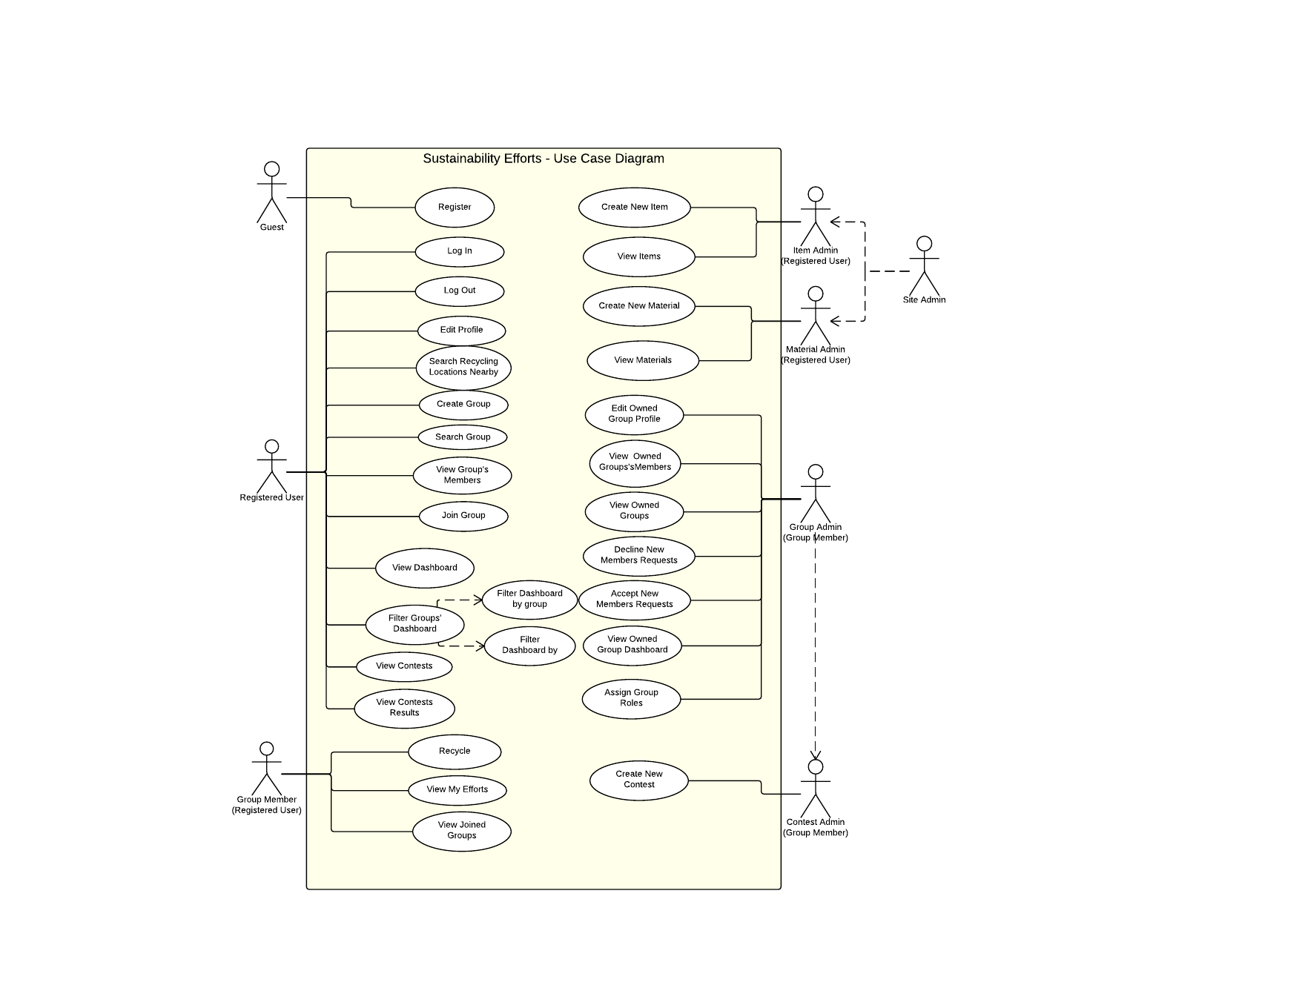

Figure 4.2.2.1- Use Case Diagram

### Static model

### Macintosh HD:Users:Monica:Downloads:Overview.jpg

Figure 4.2.3.1- Class Diagram

### Dynamic model

Refer to appendix 6.4 Appendix D

Sequence diagrams for the following functionalities

Log In

Create Account

Create Group

Edit Profile

Edit Groups Profile

Create Contest

View Contest

View Contest Activity

Recycle Item

View groups Activity (dashboard)

View User Scoreboard

View Item Scoreboard

View Group Scoreboard

View Site Usage

Filter Dashboard

# Glossary

|  |  |
| --- | --- |
| **Term** | **Definition** |
| Guest User | A user that has not created an account in the system |
| Registered User | A user that has created an account in the system |
| Group Owner | A user that created a group is automatically that group’s owner |
| Group Member | A registered user that joined a group. |

# Appendix

## Appendix A - Complete use cases

|  |  |
| --- | --- |
| Use Case ID | US1001 |
| Description | Allows a Guest to create an account and become a registered user. |
| Actor | Guest |
| Pre-conditions | 1. The Guest accesses the home page of the application. |
| Steps | 1. The Guest fills out the required user account information. 2. The Guest clicks on “Create Account” button. 3. The user account information is validated by the System. 4. The user account information is created by the System. 5. The Guest is notified that the account has been created. |
| Post-Conditions | 1. The Guest is now a registered user in the system. |
| Exceptions | Exception: User account information is invalid  Raised when any of the user information fields contains invalid information. |

|  |  |
| --- | --- |
| Use Case ID | US1002 |
| Description | A Registered User should be able to login into the system. |
| Actor | Registered User |
| Pre-conditions | 1. The Registered User access the home page of the application. |
| Steps | 1. The Registered User fills out his credentials. 2. The Register User clicks on “Sign in”. 3. The system validates the credentials. 4. The system logs in the Registered User. 5. The system redirects the user to the User Home page. |
| Post-Conditions | 1. The user has access to site data |
| Exceptions | Exception: User/Password incorrect  Raised when the entered credentials do not match anything in the system. |

|  |  |
| --- | --- |
| Use Case ID | US1003 |
| Description | A Registered User should be able to edit their user profile in the system to keep it up to date. |
| Actor | Registered User |
| Pre-conditions | 1. The Registered User accesses the home page of the application. 2. The Registered User logs into the application. 3. The Registered User clicks the “User” menu item. |
| Steps | 1. The Registered User clicks the “Edit Profile” menu item. 2. The Registered User changes the user account information as need be. 3. The Registered User clicks on “Save” button. 4. The System validates the user account information. 5. The System updates the user account information. 6. The Registered User receives notification the user account information was updated. |
| Post-Conditions | 1. The new information is stored in the database |
| Exceptions | Exception: User account information is invalid  Raised when any of the user account information fields contains invalid information. |

|  |  |
| --- | --- |
| Use Case ID | US1004 |
| Description | A Registered User should be able to view the overall group’s activity of the site. |
| Actor | Registered User |
| Pre-conditions | 1. The Registered User logs into the application. 2. The Registered User accesses the user home page of the application. |
| Steps | 1. The System shall retrieve groups, recycled and users activity 2. The system shall display the information on the dashboard |
| Post-Conditions | 1. The user can see the group, users and items activity |
| Exceptions | Exception: System is not able to retrieve data |

|  |  |
| --- | --- |
| Use Case ID | US1005 |
| Description | A Registered User should be able to send a request to a group they are not a member of, to join the group. |
| Actor | Registered User |
| Pre-conditions | 1. The Registered User accesses the home page of the application. 2. The Registered User logs into the application. 3. The Registered User clicks the “Groups” menu item. 4. The Registered User clicks the “Search Group” menu item. |
| Steps | 1. The Registered User searches and clicks on the Group they wish to join. 2. The Registered User clicks on “Join” button. 3. The Registered User receives notification the request was sent. |
| Post-Conditions | 8. The notification is added to the queue of that group’s administrator |
| Exceptions |  |

|  |  |
| --- | --- |
| Use Case ID | US1008 |
| Description | A Registered User should be able to create a new group. |
| Actor | Registered User |
| Pre-conditions | 1. The Registered User accesses the home page of the application. 2. The Registered User logs into the application. 3. The Registered User clicks the “Groups” menu item. |
| Steps | 1. The Registered User clicks the “Create Group” menu item. 2. The Registered User fills out the group account information. 3. The Registered User clicks on the “Save” button. 4. The System validates the group account information. 5. The System group account information is created by the system. 6. The Registered User receives notification the group has been created. |
| Post-Conditions | The Registered User is assigned as the Group Owner of the created group. |
| Exceptions |  |

|  |  |
| --- | --- |
| Use Case ID | US1009 |
| Description | A Registered User can log recycling actions. |
| Actor | Registered User |
| Pre-conditions | 1. The Registered User accesses the home page of the application. 2. The Registered User logs into the application. |
| Steps | 1. The Registered User clicks the “Recycle” menu item. 2. The Registered User selects the appropriate information for the recycling action. 3. The Registered User clicks on the “Create Recycling Action” button. 4. The system will add the new recycling action. 5. The system shall verify if the recycled item is part of a contest. 6. The Registered User receives notification that the recycling action has been created. |
| Post-Conditions | The system displays success/failure message |
| Exceptions |  |

|  |  |
| --- | --- |
| Use Case ID | US1011 |
| Description | A Registered User can see recycling locations near by. |
| Actor | Registered User |
| Pre-conditions | 1. The Registered User accesses the home page of the application. 2. The Registered User logs into the application. |
| Steps | 1. The Registered User clicks the “Recycle Locations” menu item. |
| Post-Conditions |  |
| Exceptions | The system is not able to retrieve location. |

|  |  |
| --- | --- |
| Use Case ID | US1012 |
| Description | A Registered User can review all materials created in the system. |
| Actor | Registered Users |
| Pre-conditions | 1. The Registered User accesses the home page of the application. 2. The Registered User logs into the application. |
| Steps | 1. The Registered User clicks the “Materials” menu item. 2. The system shall retrieve the materials information from the database. |
| Post-Conditions | The system displays the list of materials |
| Exceptions |  |

|  |  |
| --- | --- |
| Use Case ID | US1013 |
| Description | A Material Administrator wants to create a new Material. |
| Actor | Material Administrator |
| Pre-conditions | 1. The Material Administrator accesses the home page of the application. 2. The Material Administrator logs into the application. |
| Steps | 1. The Material Administrator clicks the “Item” menu item. 2. The Material Administrator clicks the “New Material” menu item. 3. The Material Administrator fills out the new material information. 4. The Material Administrator clicks on “Create Material” button. 5. The System validates the new material information. 6. The System creates the new material. 7. The Material Administrator is notified that the material was created. |
| Post-Conditions |  |
| Exceptions | Exception: New material information is invalid  Raised when any of the new material information fields contains invalid information. |

|  |  |
| --- | --- |
| Use Case ID | US1014 |
| Description | A Registered User should be able to review Items in the System. |
| Actor | Registered User |
| Pre-conditions | 1. The Registered User accesses the home page of the application. 2. The Registered User logs into the application. |
| Steps | 1. The Registered User clicks the “Item” menu item. 2. The Registered User clicks the “Items” menu item. |
| Post-Conditions |  |
| Exceptions |  |

|  |  |
| --- | --- |
| Use Case ID | US1015 |
| Description | An Item Administrator wants to create a new Item. |
| Actor | Item Administrator |
| Pre-conditions | 1. The Item Administrator accesses the home page of the application.   2. The Item Administrator logs into the application. |
| Steps | 1. The Item Administrator clicks the “Item” menu item. 2. The Item Administrator clicks the “New Item” menu item. 3. The Item Administrator types in some information on the new item and clicks on “Next” button. 4. The Item Administrator confirms this item is not already in the System. 5. The Item Administrator enters the new item information. 6. The Item Administrator clicks on “Create Item” button. 7. The System validates the new item information. 8. The System creates the new item. |
| Post-Conditions | The Item Administrator is notified that the material was created. |
| Exceptions | Exception: New item information is invalid  Raised when any of the new item information fields contains invalid information. |

|  |  |
| --- | --- |
| Use Case ID | US1016 |
| Description | A Registered User can view groups they are members of. |
| Actor | Registered User |
| Pre-conditions | 1. The Registered User accesses the home page of the application. 2. The Registered User logs into the application. |
| Steps | 1. The Registered User clicks the “Groups” menu item. 2. The Registered User clicks the “Joined Groups” menu item. 3. The system shall list the groups the user has joined |
| Post-Conditions |  |
| Exceptions |  |

|  |  |
| --- | --- |
| Use Case ID | US1018 |
| Description | A Registered User can view the members of a group they have joined. |
| Actor | Registered User |
| Pre-conditions |  |
| Steps | 1. The Registered User accesses the home page of the application. 2. The Registered User logs into the application. 3. The Registered User clicks the “Groups” menu item. 4. The Registered User clicks the “Joined Groups” menu item. 5. The Registered User clicks on a Group. 6. The Registered User clicks the “members” button. 7. The Registered User is shown all members of that Group. |
| Post-Conditions |  |
| Exceptions |  |

|  |  |
| --- | --- |
| Use Case ID | US1020 |
| Description | A registered user can log out |
| Actor | Registered User |
| Pre-conditions | 1. The Registered User accesses the home page of the application. 2. The Registered User logs into the application. |
| Steps | 1. The Registered User accesses User drop down menu 2. The registered user click log out 3. The system shall log out the user from the application |
| Post-Conditions | 6. The user cannot access any functionality of the application without logging in again |
| Exceptions |  |

|  |  |
| --- | --- |
| Use Case ID | US1021 |
| Description | A Group Administrator can edit the information of the group they administrate. |
| Actor | Group Administrator |
| Pre-conditions | 1. The Group Administrator accesses the home page of the application. 2. The Group Administrator logs into the application. 3. The Group Administrator clicks the “Groups” menu item. 4. The Group Administrator clicks the “My Groups” menu item. |
| Steps | 1. The Group Administrator clicks on a Group. 2. The Group Administrator clicks the “edit” button. 3. The Group Administrator updates the Group information that needs update. 4. The Group Administrator clicks on the “save” button. 5. The System validates the information. 6. The System updates the new information for the group. |
| Post-Conditions |  |
| Exceptions | Exception: Group information is invalid  Raised when any of the group information fields contains invalid information. |

|  |  |
| --- | --- |
| Use Case ID | US1022 |
| Description | A Group Administrator can accept or decline users from joining the groups they own. |
| Actor | Group Administrator |
| Pre-conditions | 1. The Group Administrator accesses the home page of the application. 2. The Group Administrator logs into the application. |
| Steps | 1. The Group Administrator clicks the “Groups” menu item. 2. The Group Administrator clicks the “Accept Users” menu item. 3. The Group Administrator clicks on a Group. 4. The Group Administrator clicks the “Requests” button. 5. The Group Administrator clicks on a user and clicks “Accept” or “Reject”. |
| Post-Conditions | The user is deleted from the group owner’s request queue |
| Exceptions |  |

|  |  |
| --- | --- |
| Use Case ID | US1023 |
| Description | A Group Administrator or authorized user can create a contest |
| Actor | Group Administrator/Authorized user |
| Pre-conditions | 1. The actor accesses the home page of the application. 2. The actor logs into the application. |
| Steps | 1. The Actor clicks on Contest menu item. 2. The Actor clicks the “New Contest” menu item. 3. The Actor fills out the required information 4. The actor clicks create contest |
| Post-Conditions | The contest is stored in the database and available |
| Exceptions | The actor entered incorrect contest information and the system cannot create the contest |

|  |  |
| --- | --- |
| Use Case ID | US1024 |
| Description | A User should be able to view contests |
| Actor | Registered User |
| Pre-conditions | 1. The Actor accesses the home page of the application. 2. The Actor logs into the application. |
| Steps | 1. The Actor clicks the “Contest” menu item. 2. The Actor clicks the “View Contest” menu item. 3. The System shall get contest information from the database. 4. The system displays the list of groups |
| Post-Conditions | The user is able to select a contest and perform actions on them |
| Exceptions |  |

|  |  |
| --- | --- |
| Use Case ID | US1025 |
| Description | A user should be able to view contest activity |
| Actor | Registered User |
| Pre-conditions | 1. The Actor accesses the home page of the application.   2. The Actor logs into the application. |
| Steps | 1. The Actor clicks the “Contest” menu item. 2. The Actor clicks the “View Contest” menu item. 3. The actor selects a contest 4. The actor clicks view activity 5. The System shall get contest activity from the database. |
| Post-Conditions | The shall display the status of the contest |
| Exceptions |  |

|  |  |
| --- | --- |
| Use Case ID | US1026 |
| Description | A user should be able to see to search overall activity of a group. |
| Actor | Registered User |
| Pre-conditions | 1. The Actor accesses the home page of the application.   2. The Actor logs into the application. |
| Steps | 1. The system shall display groups activity in the dashboard 2. The user types a name on the group search box 3. The system shall retrieve the data associated with that group |
| Post-Conditions | The user gets information filtered by group name |
| Exceptions | The group name that the user entered does not exist |

|  |  |
| --- | --- |
| Use Case ID | US1027 |
| Description | A user should be able to see to search overall activity of a user. |
| Actor | Registered User |
| Pre-conditions | 1. The Actor accesses the home page of the application.   2. The Actor logs into the application. |
| Steps | 1. The system shall display users activity in the dashboard 2. The user types a name on the user search box 3. The system shall retrieve the data associated with that user |
| Post-Conditions | The user gets information filtered by user name |
| Exceptions | The user name that the user entered does not exist |

|  |  |
| --- | --- |
| Use Case ID | US1028 |
| Description | A user should be able to search recycled items |
| Actor | Registered User |
| Pre-conditions | 1. The Actor accesses the home page of the application.   2. The Actor logs into the application. |
| Steps | 1. The system shall display items activity in the dashboard 2. The user types a name on the items search box 3. The system shall retrieve the data associated with that item |
| Post-Conditions | The user gets information filtered by item name |
| Exceptions | The items name that the user entered does not exist |

## Appendix B - Use case diagram using UML

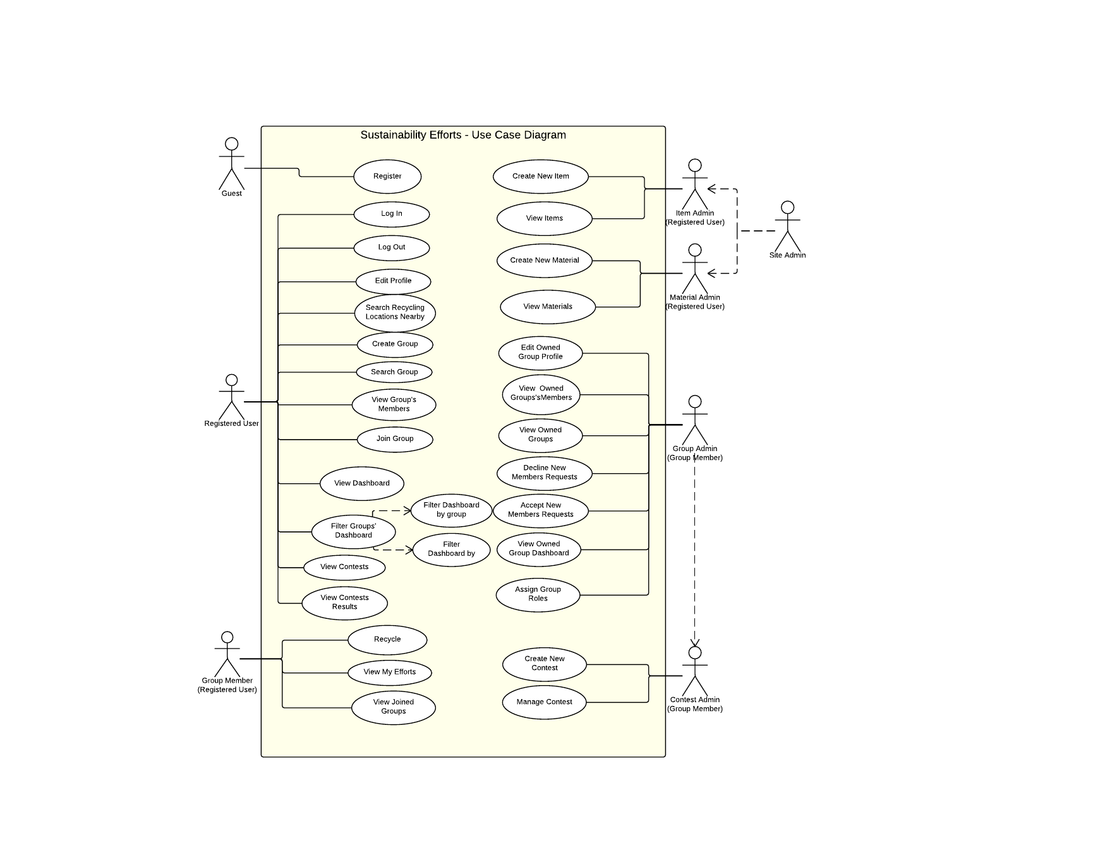

Figure 6.2.1- Use Case Diagram

## Appendix C - Static UML diagram

### Macintosh HD:Users:Monica:Downloads:Overview.jpg

Figure 6.3.1- Class Diagram

## Appendix D - Dynamic UML diagrams

## Macintosh HD:Users:Monica:Documents:School:CIS 4911:docs:Sequence Diagrams:Log In - Page 1.png

Figure 6.4.1- Log In

## Macintosh HD:Users:Monica:Documents:School:CIS 4911:docs:Sequence Diagrams:Edit Profile - Page 1.png

Figure 6.4.2- Edit Profile

## Macintosh HD:Users:Monica:Documents:School:CIS 4911:docs:Sequence Diagrams:Create Account - Page 1.png

Figure 6.4.3 Create Account

## Macintosh HD:Users:Monica:Documents:School:CIS 4911:docs:Sequence Diagrams:Create Group - Page 1.png

Figure 6.4.4- Create Group

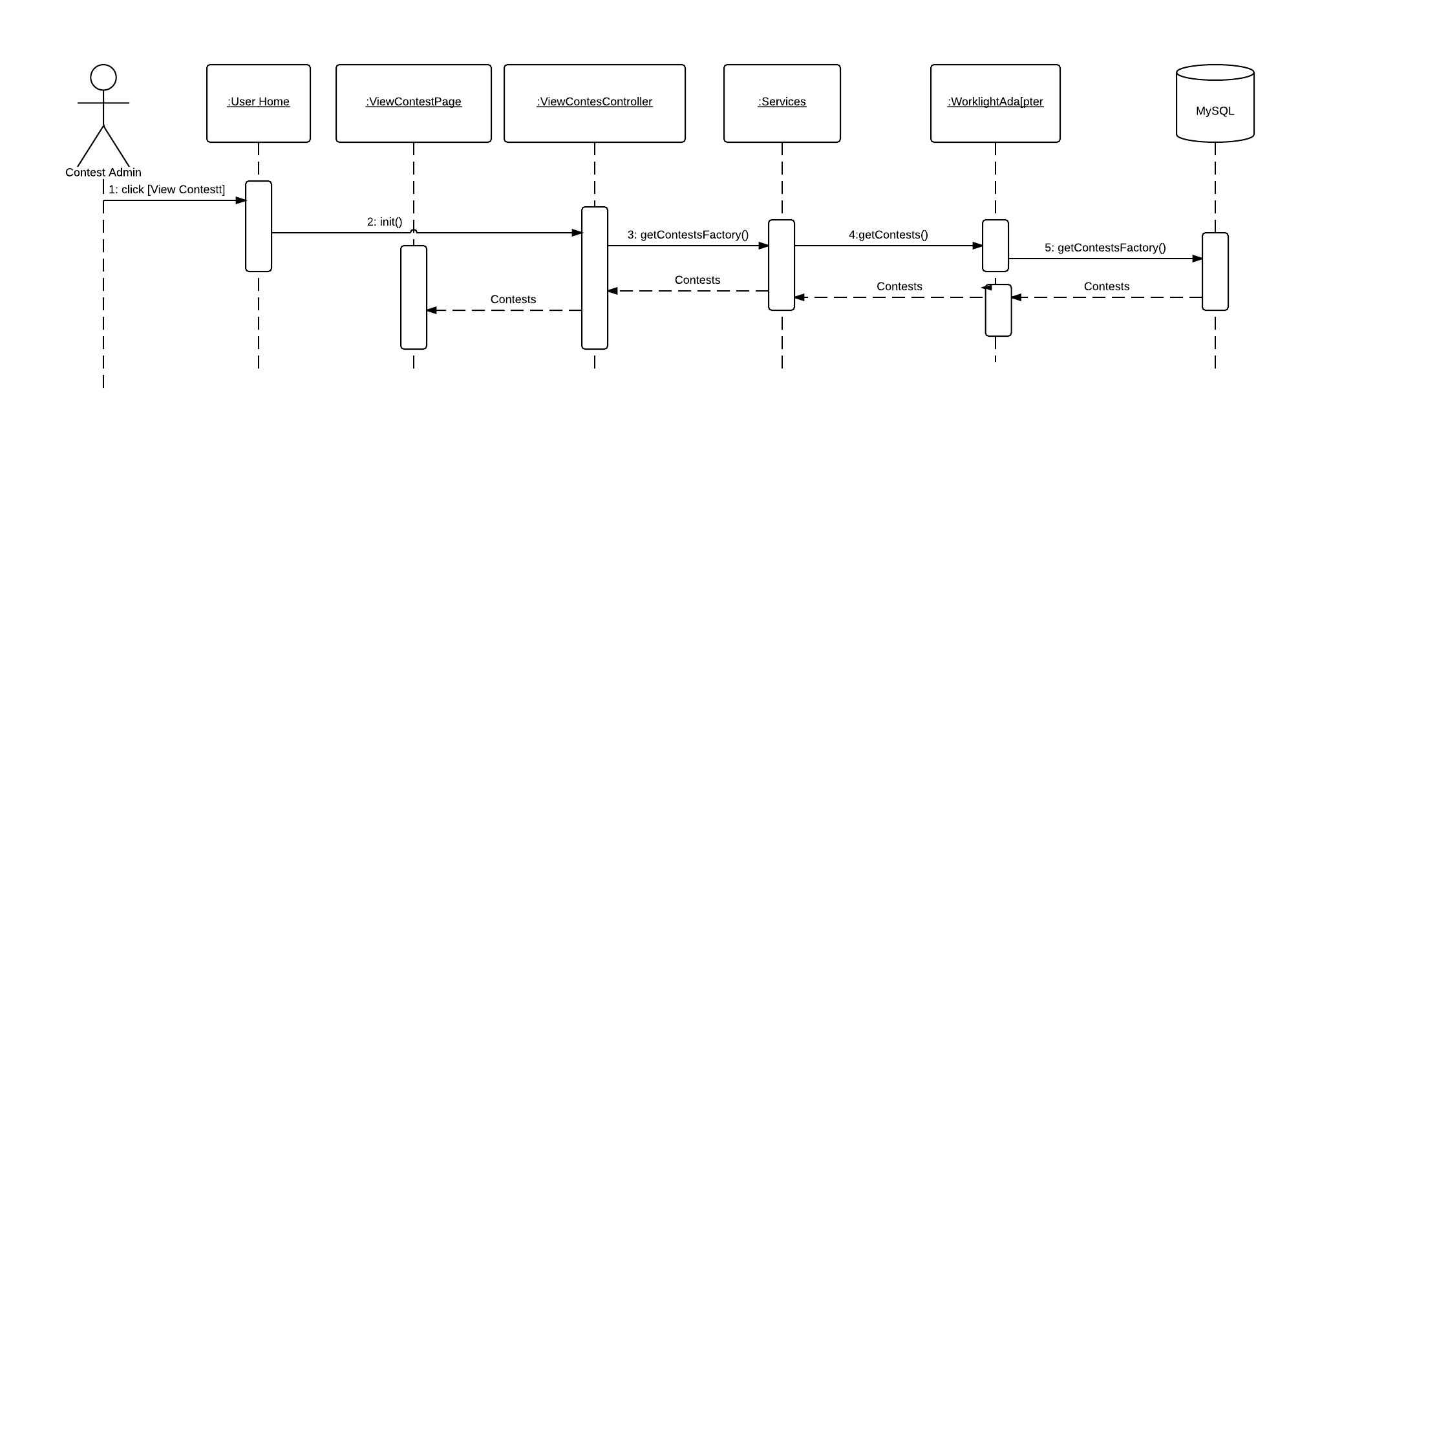

Figure 6.4.5 Create Contest

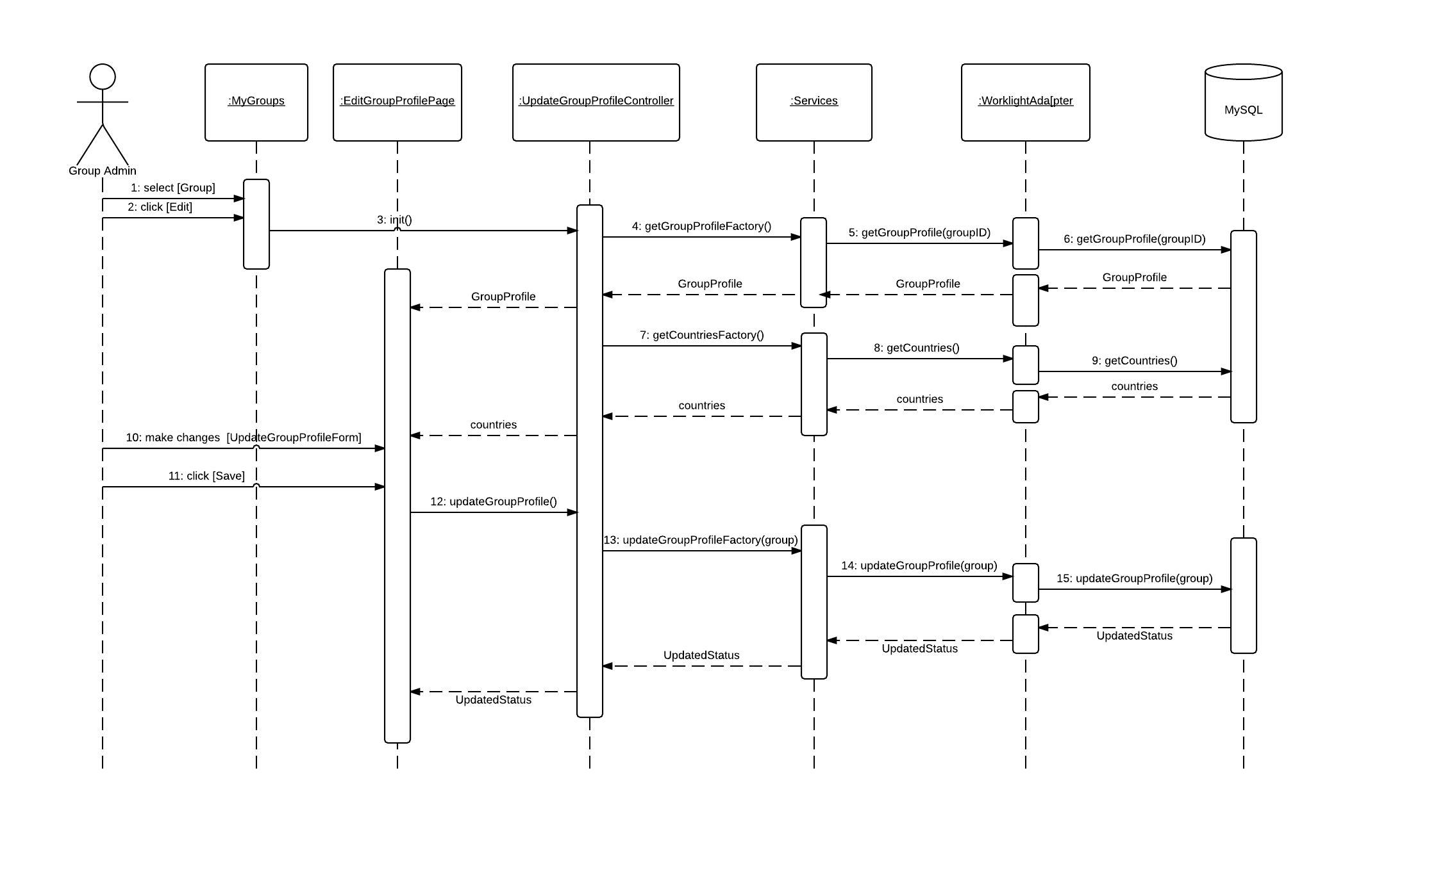

Figure 6.4.6 – Edit Group Profile

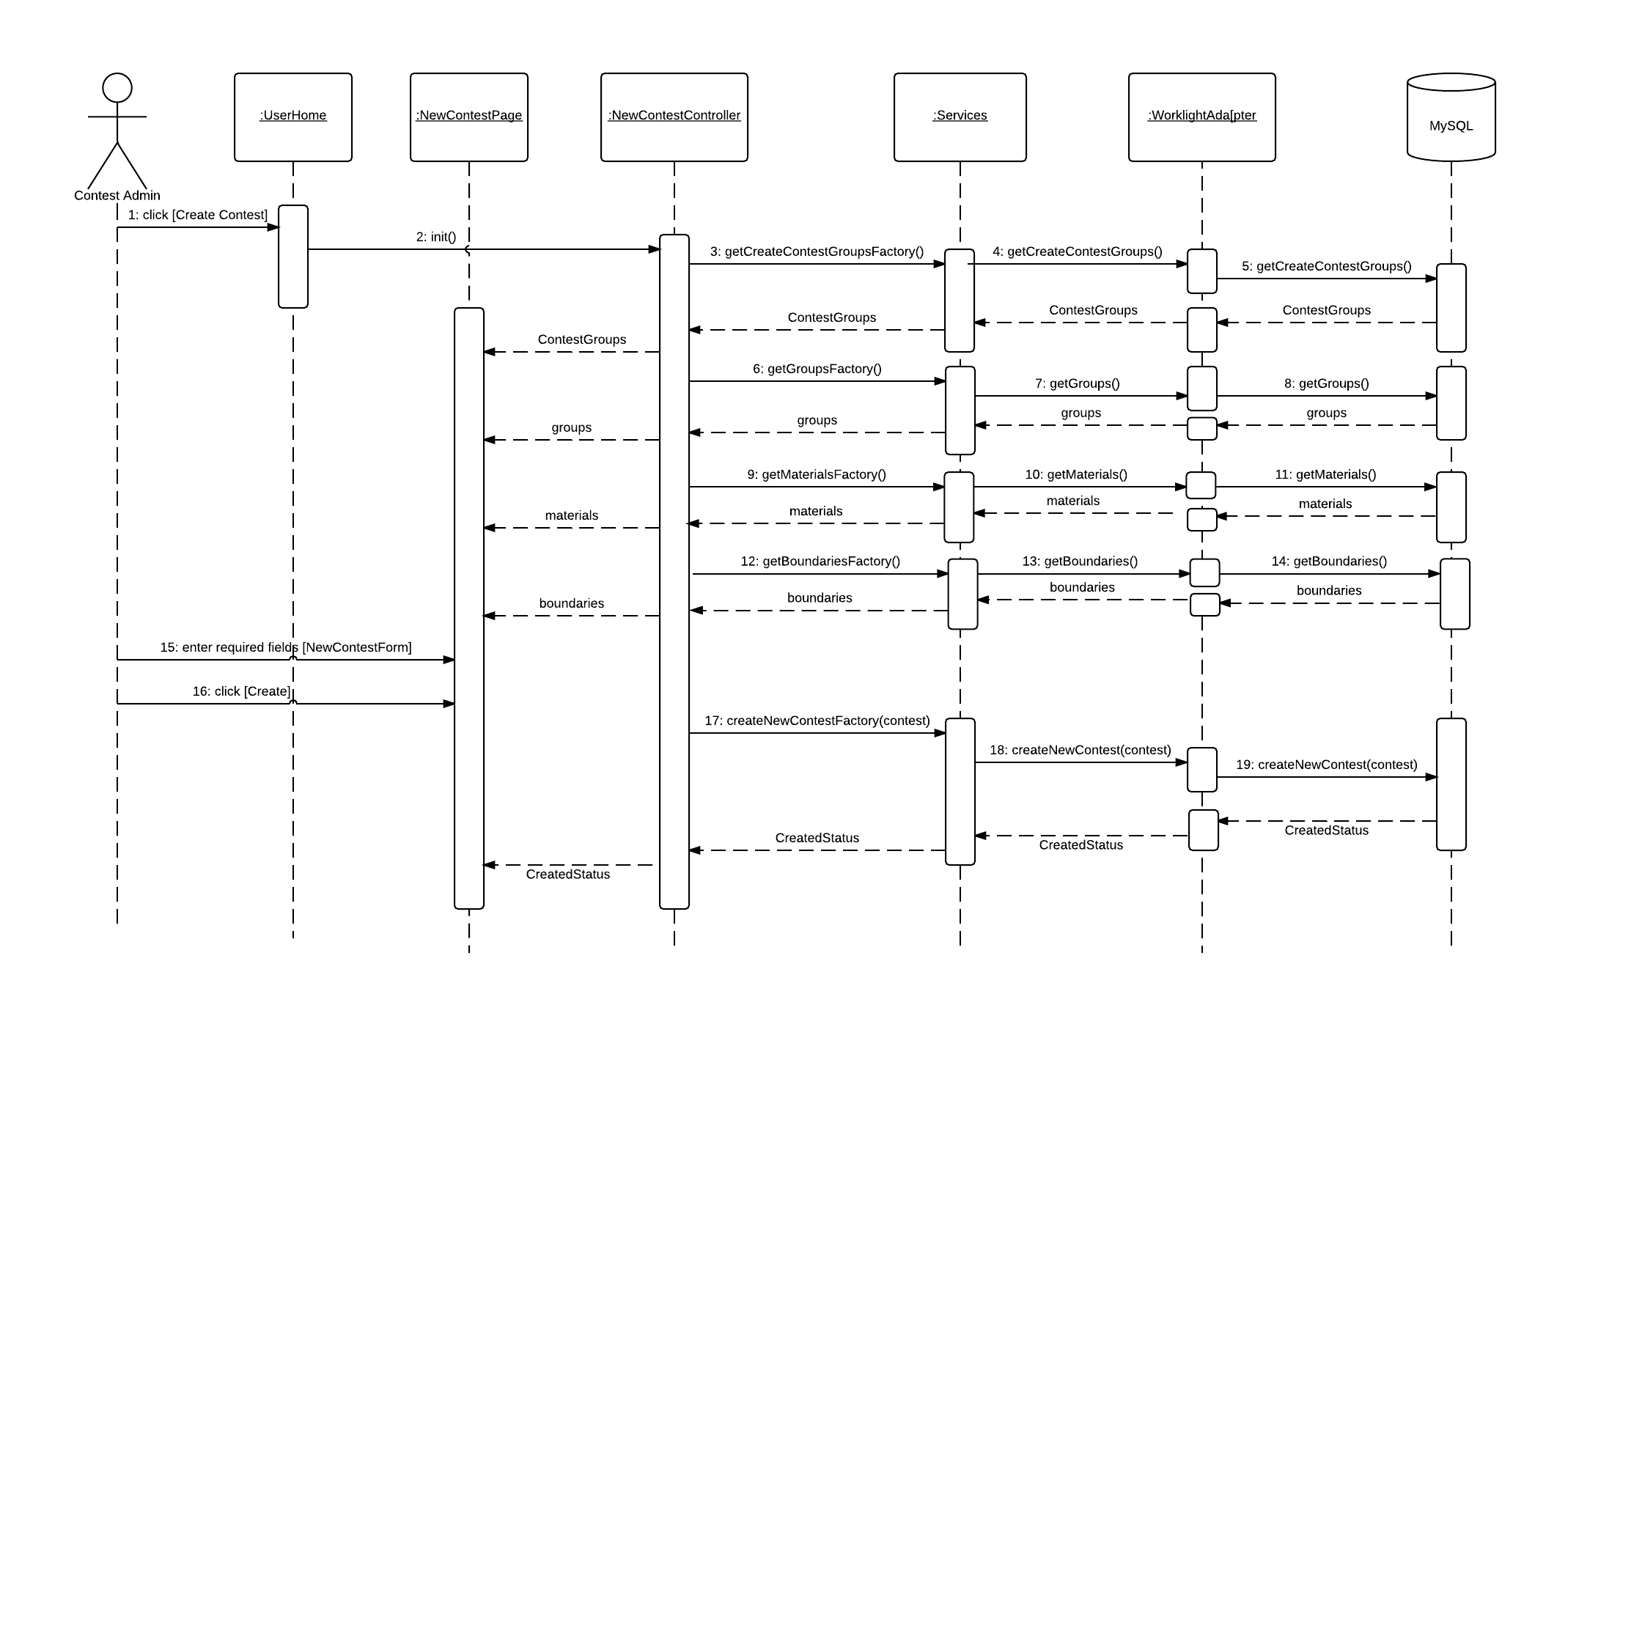

Figure 6.4.7 View Contest

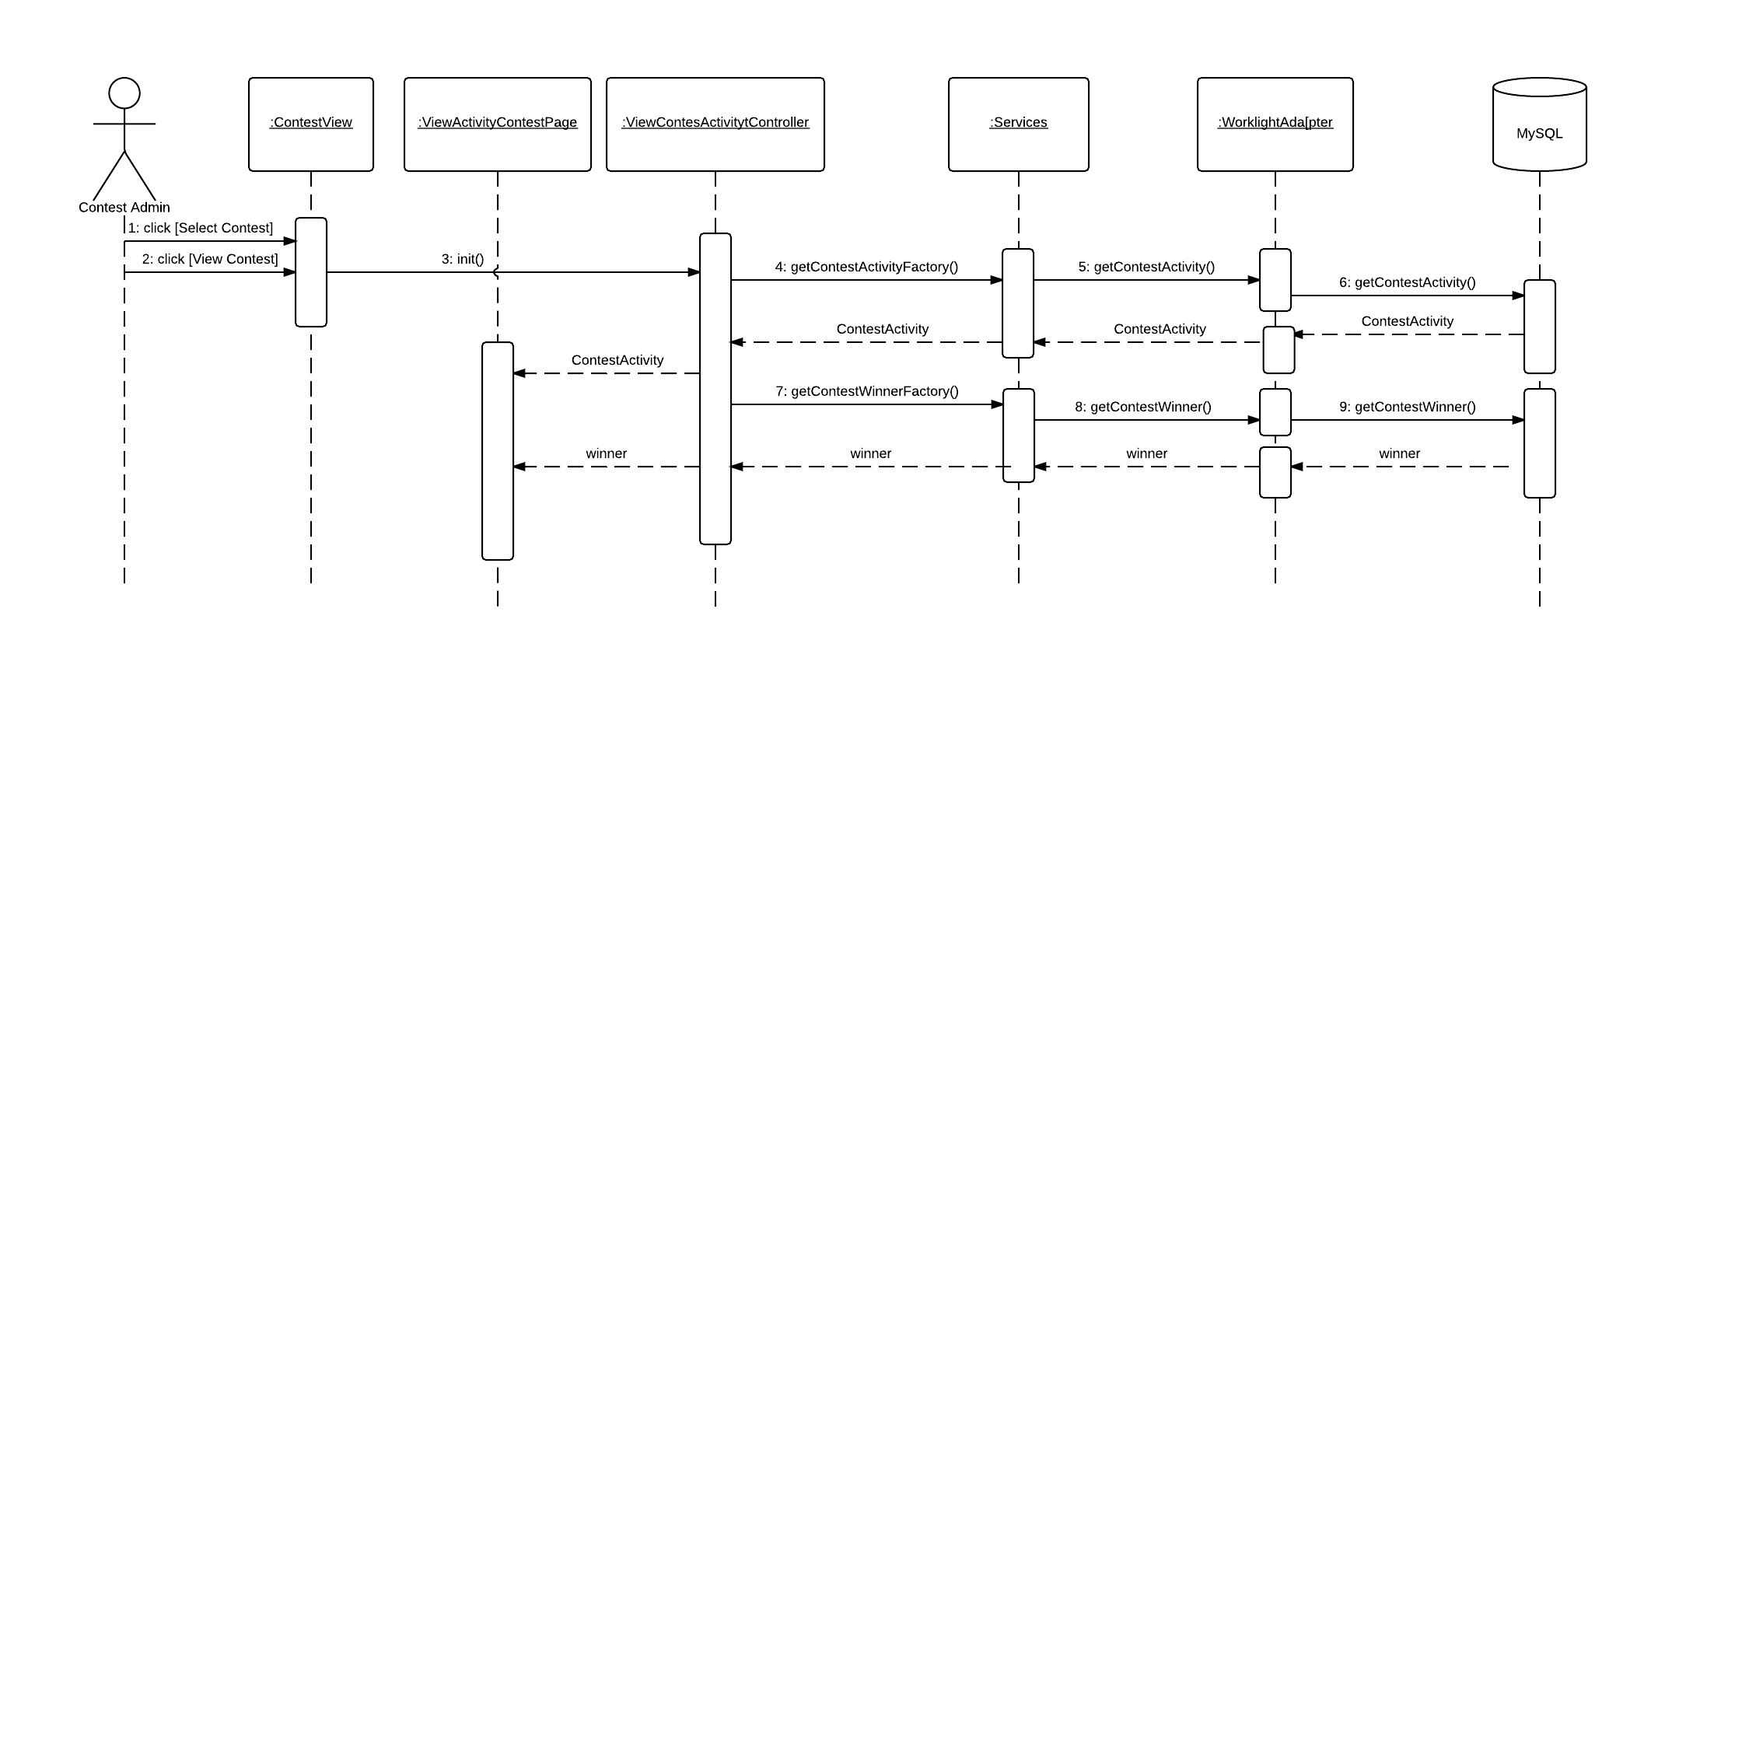

Figure 6.4.8- View Contest Activity

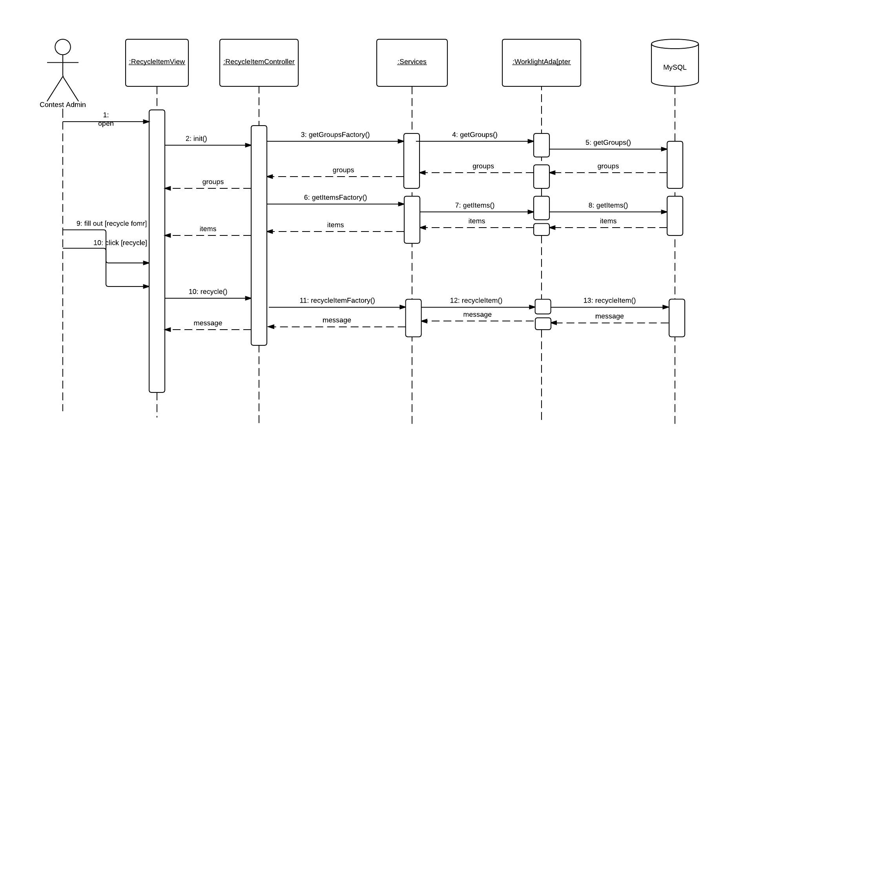

Figure 6.4.9- Recycle Item

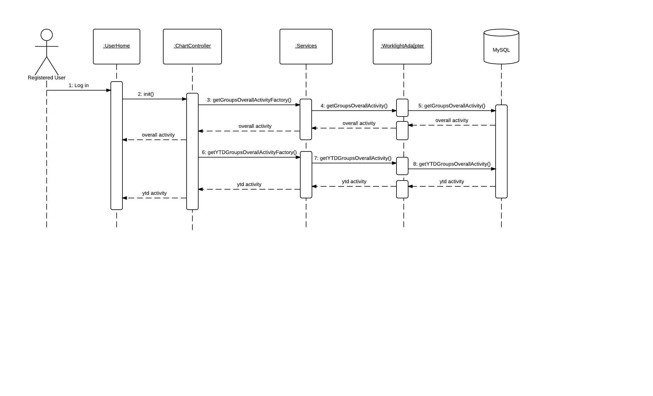

Figure 6.4.10 – Dashboard Charts

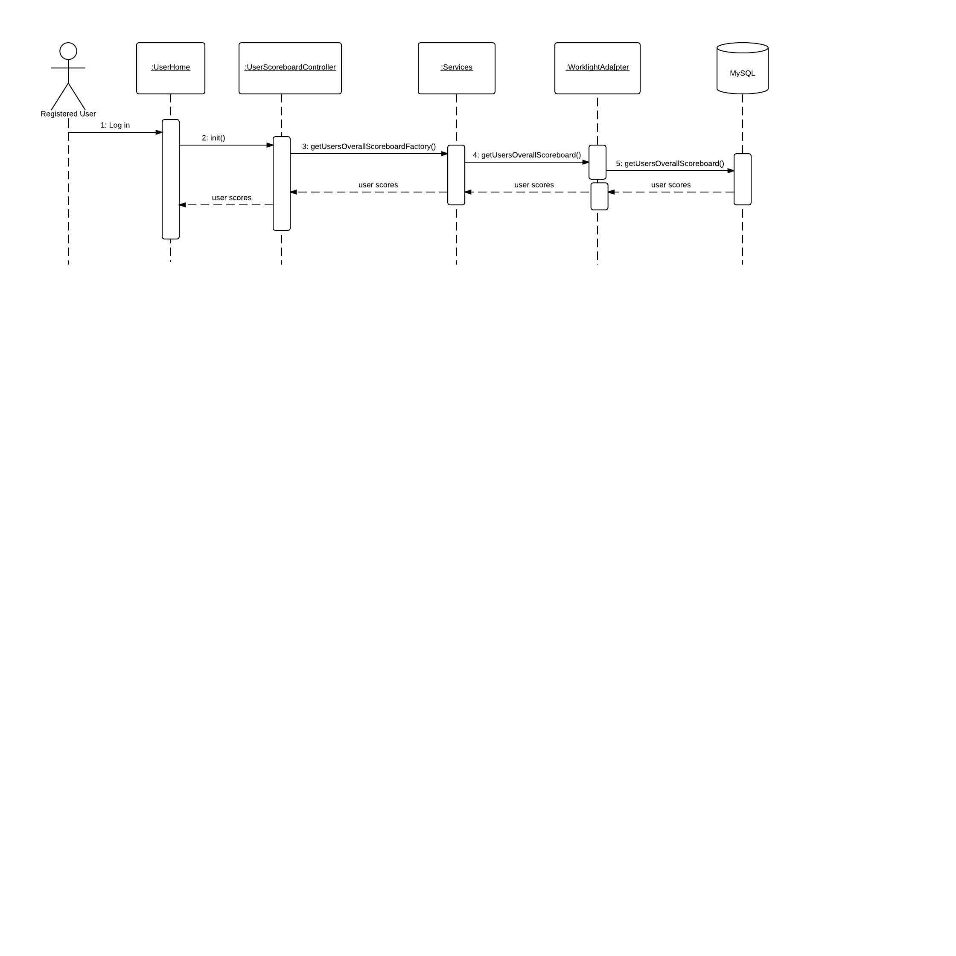

Figure 6.4.11- User Scoreboard

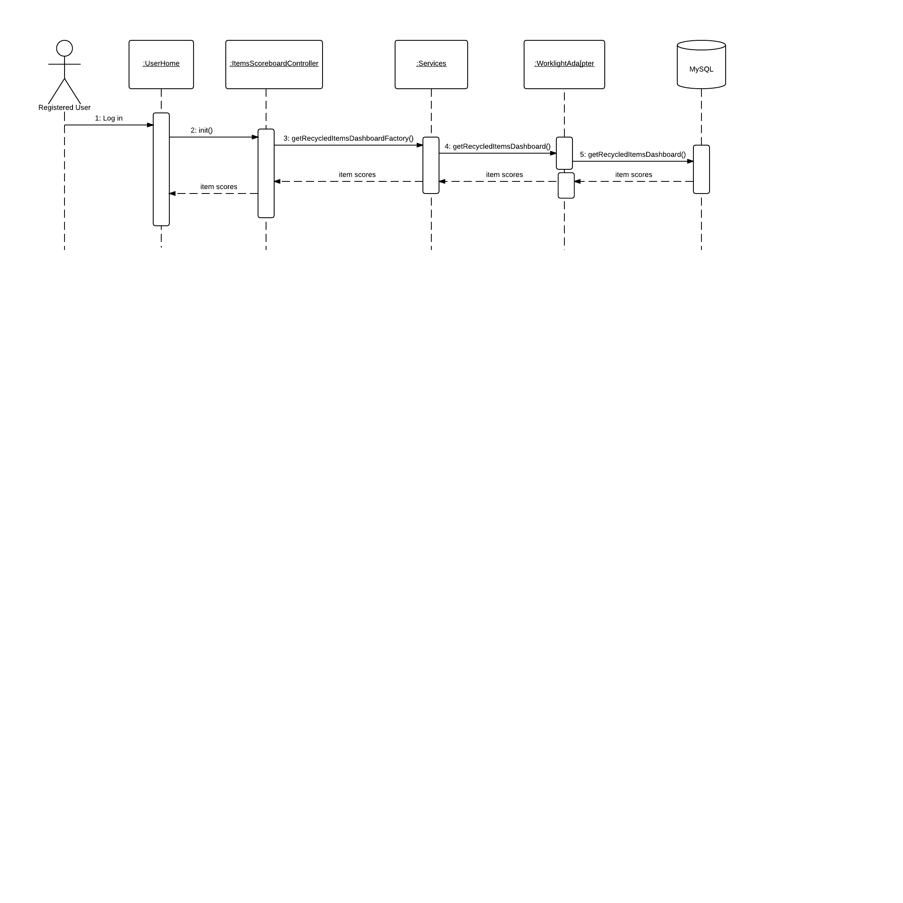

Figure 6.4.12- Item Scoreboard

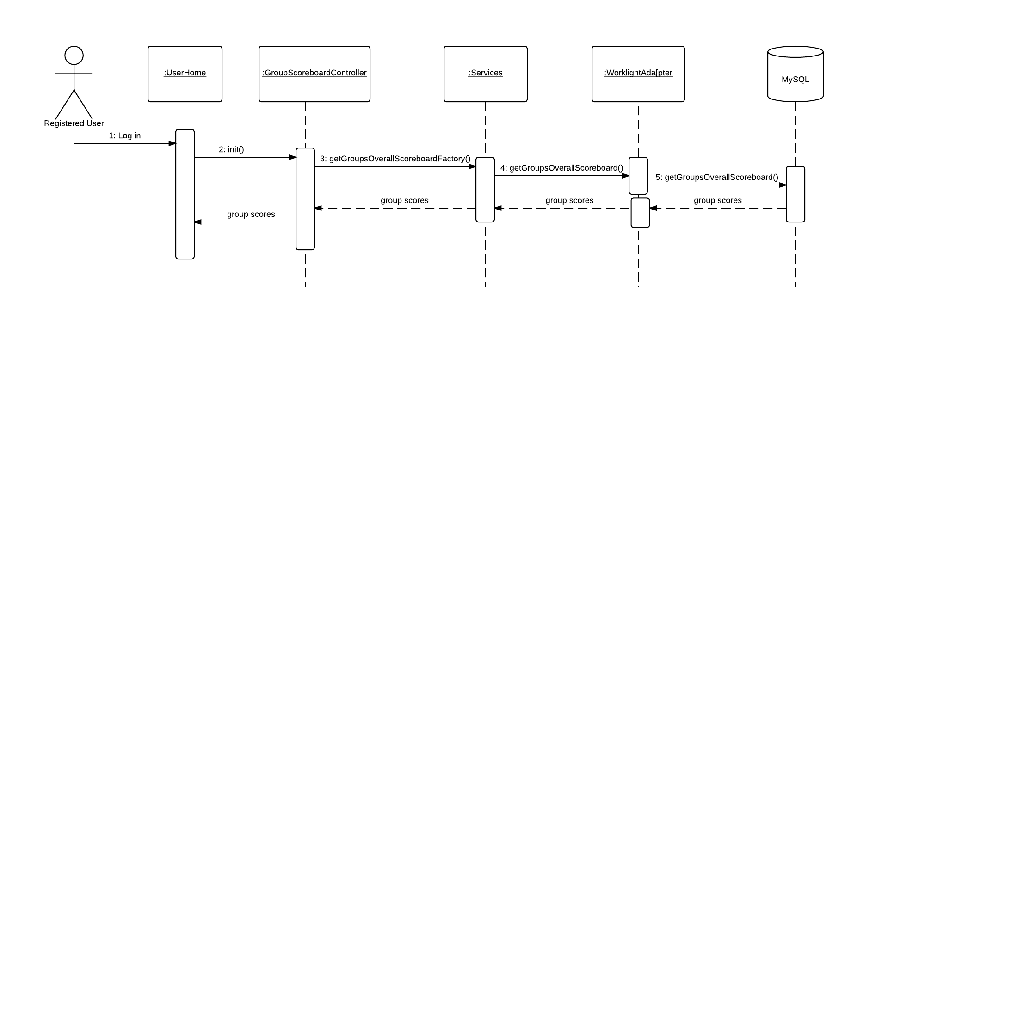

Figure 6.4.13- Group Scoreboard

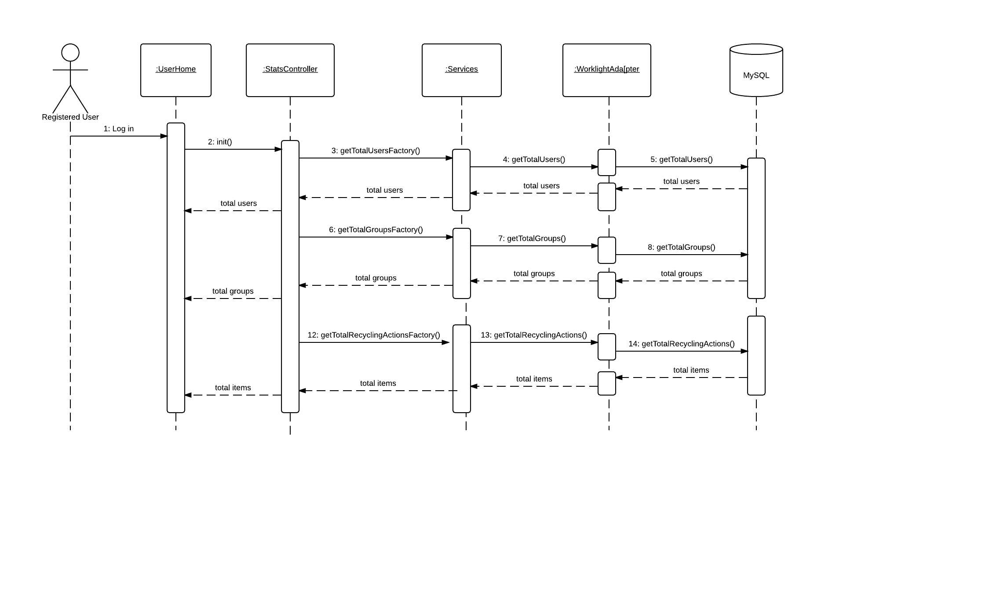

Figure 6.4.14- Site Usage widgets

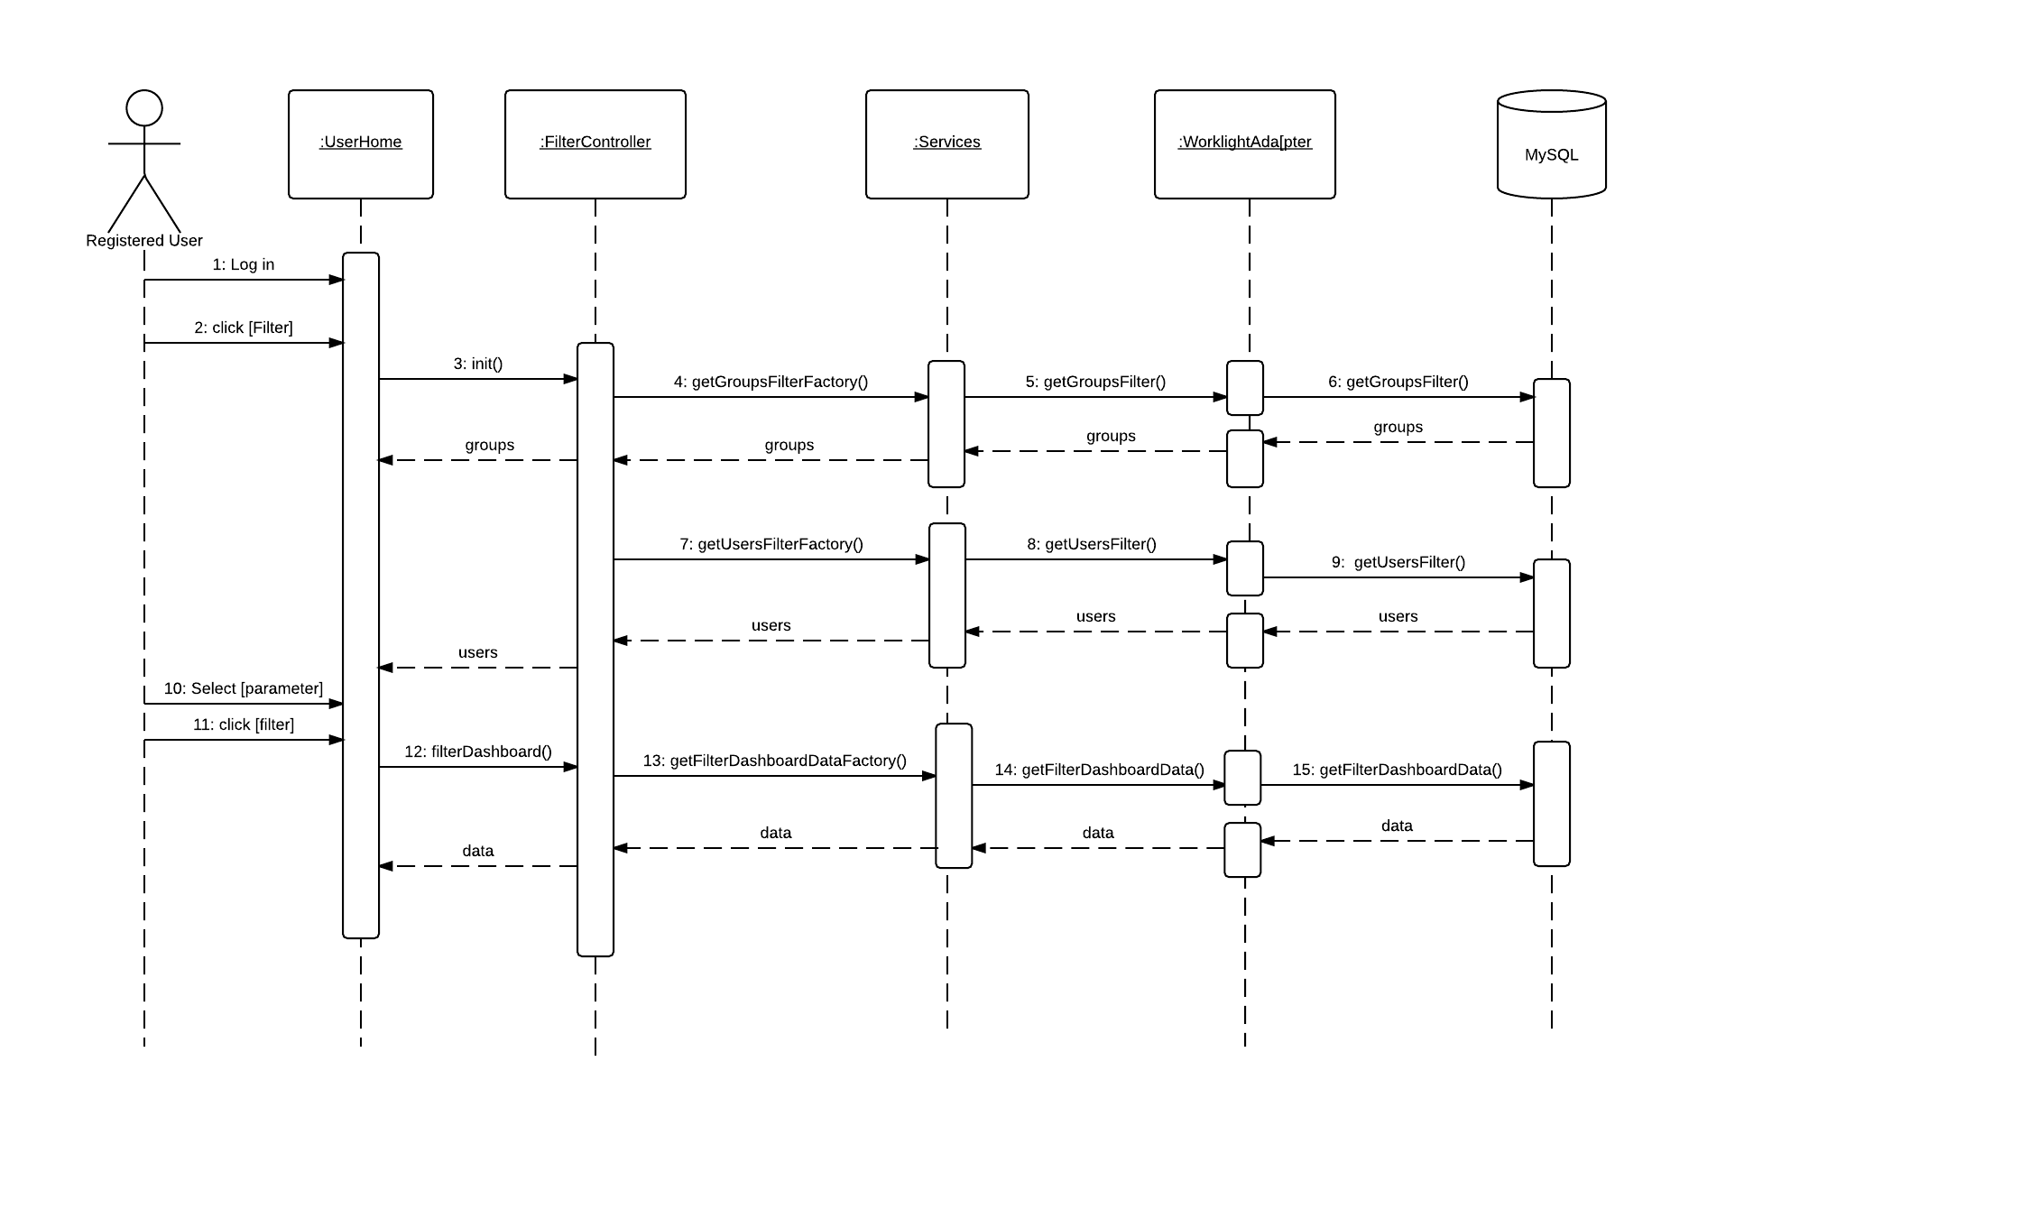

Figure 6.4.15- Filter Dashboard

## Appendix E - User Interface designs.

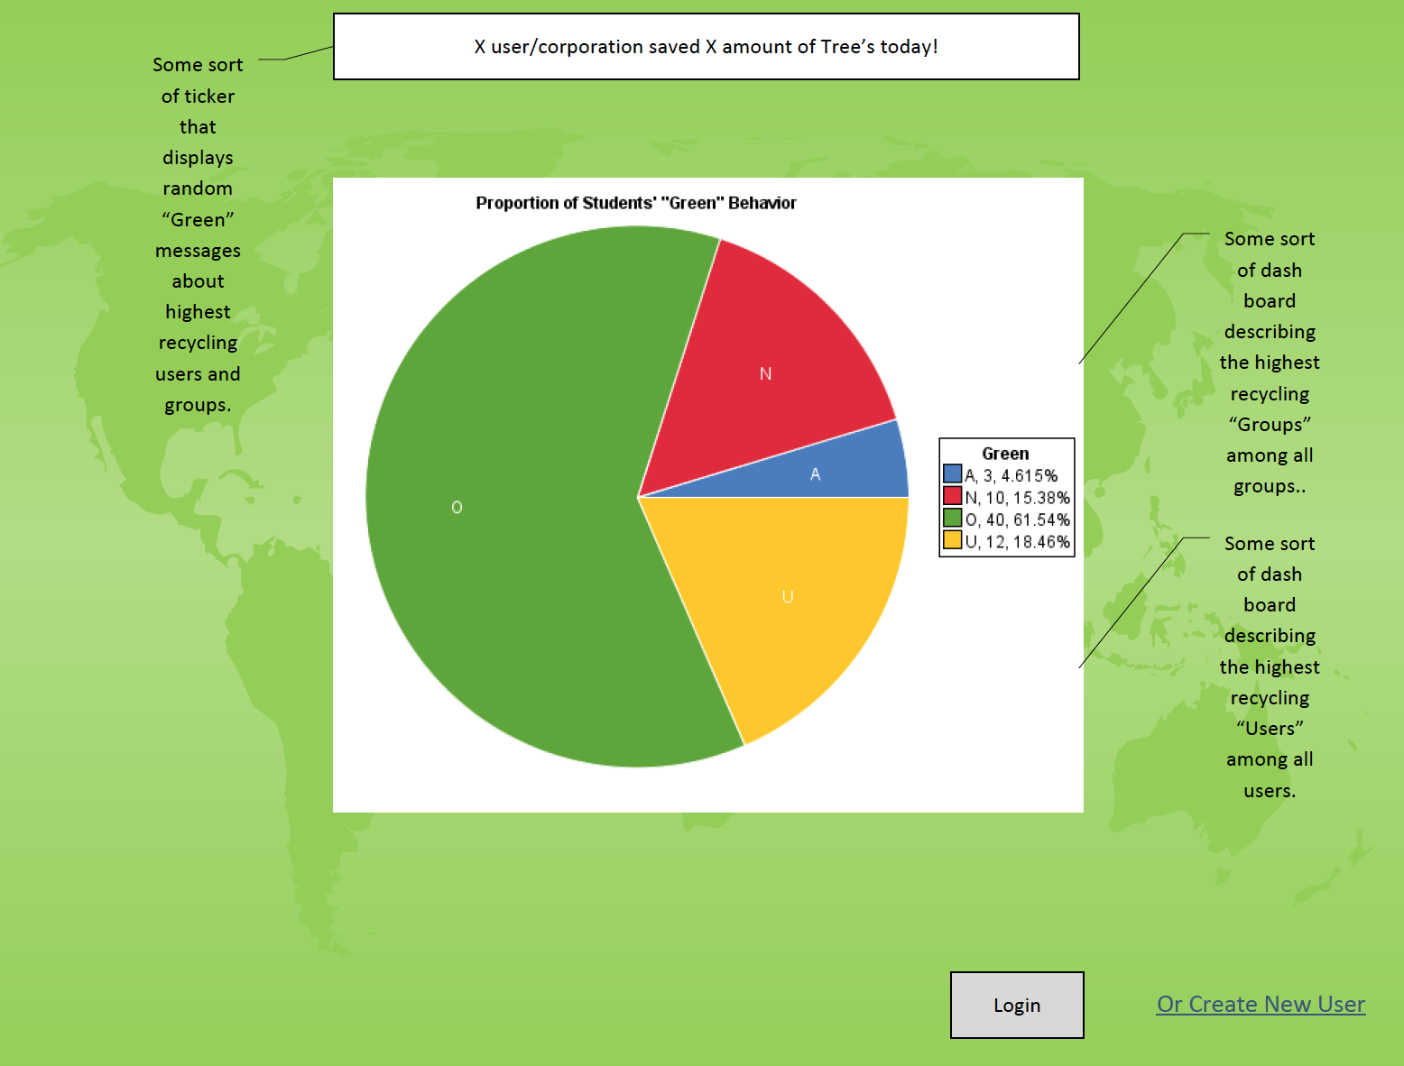

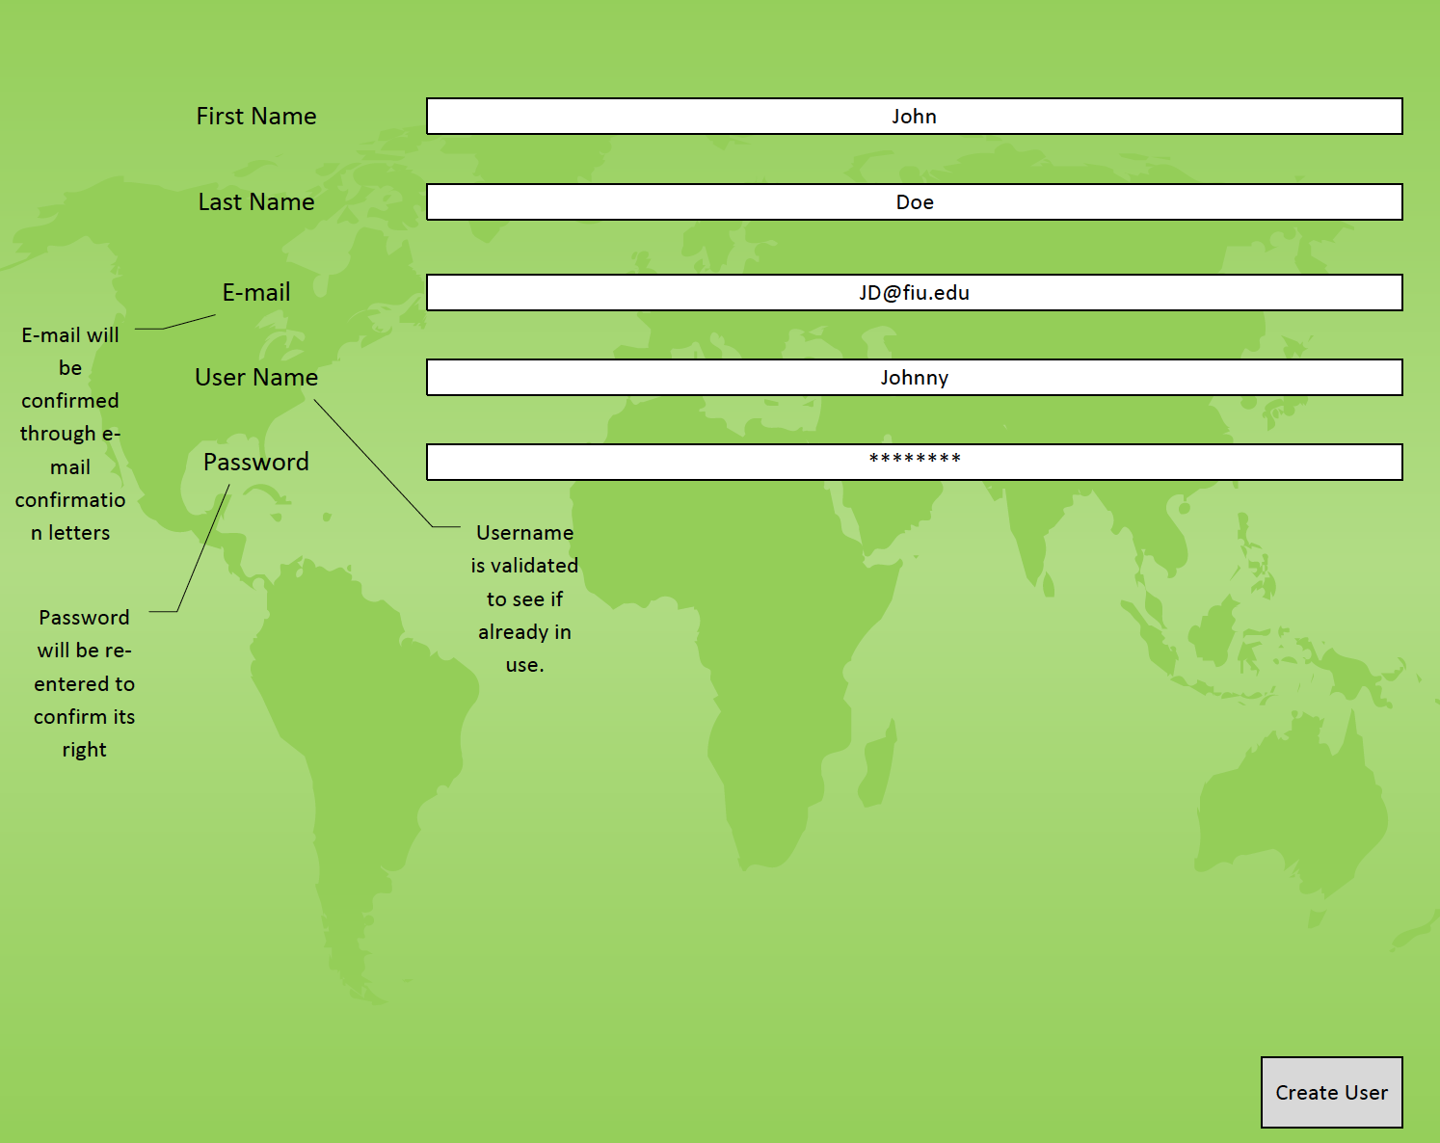

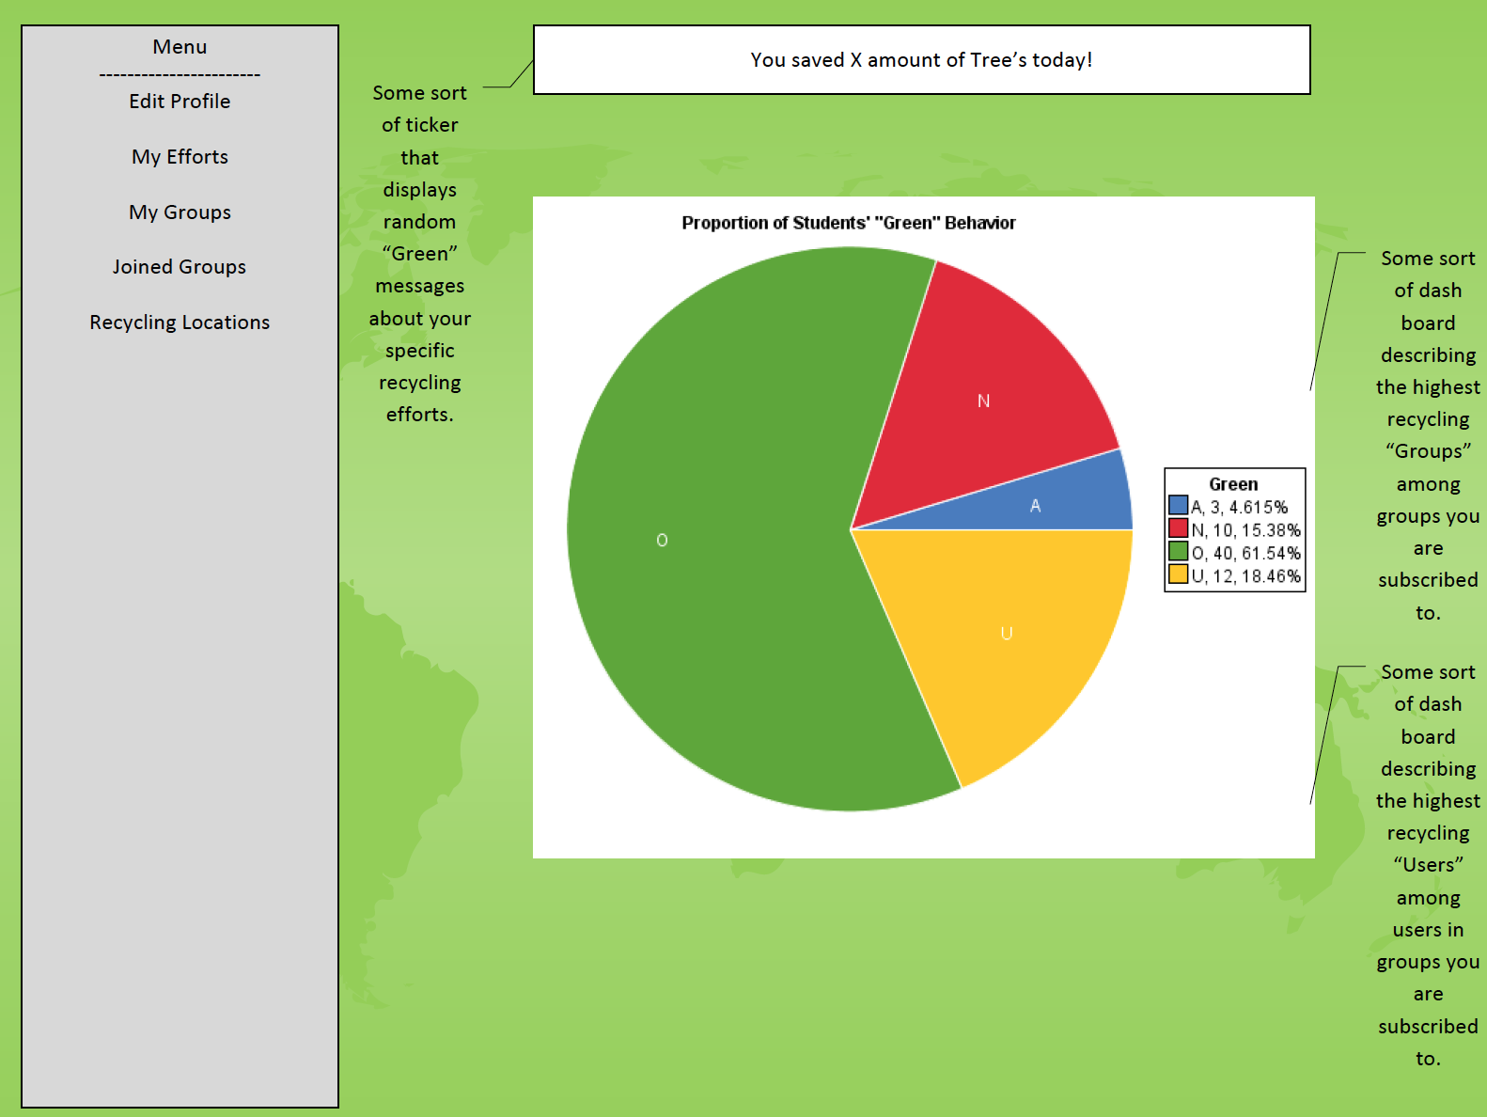

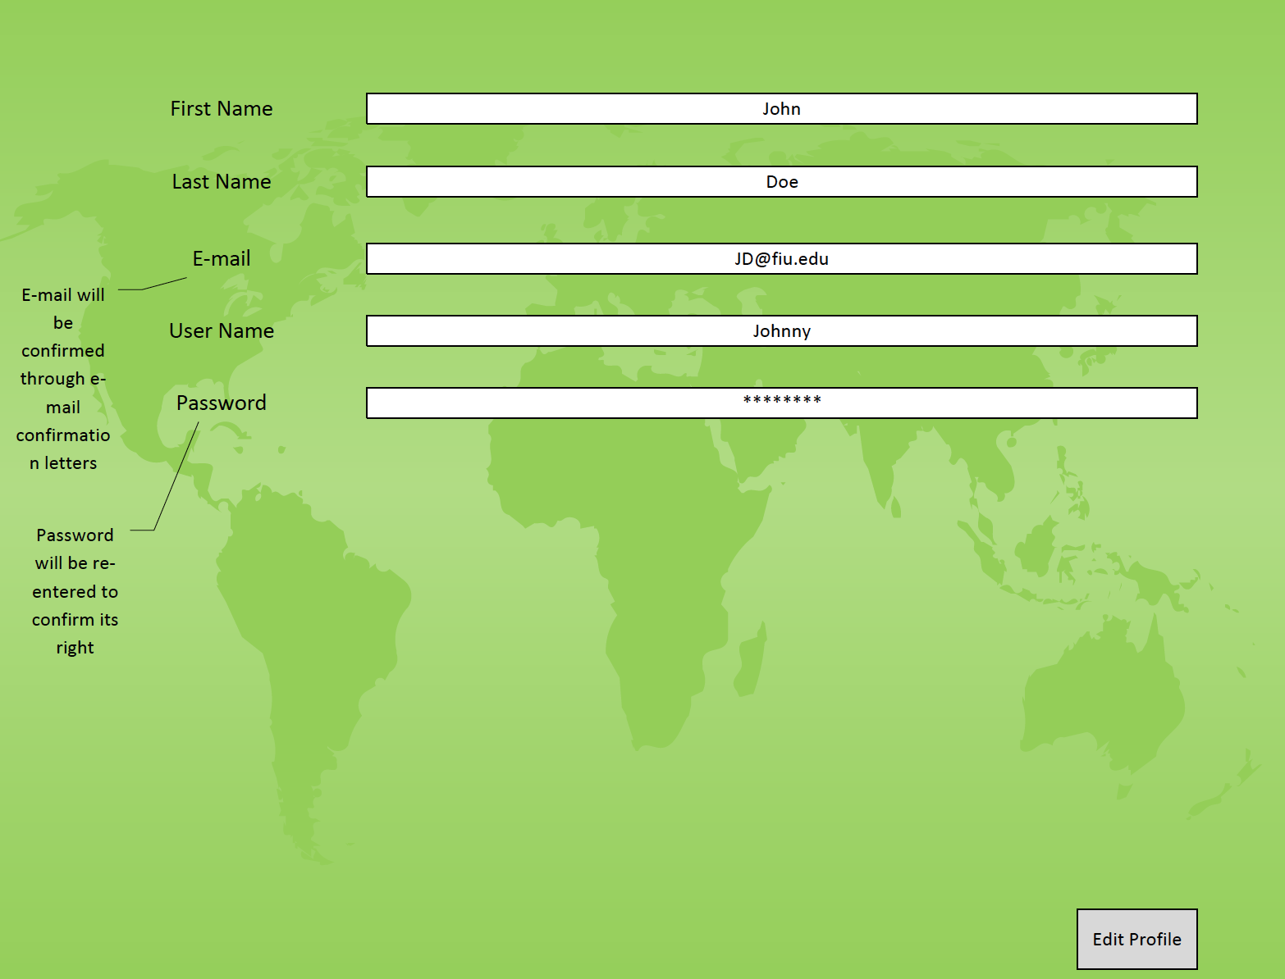

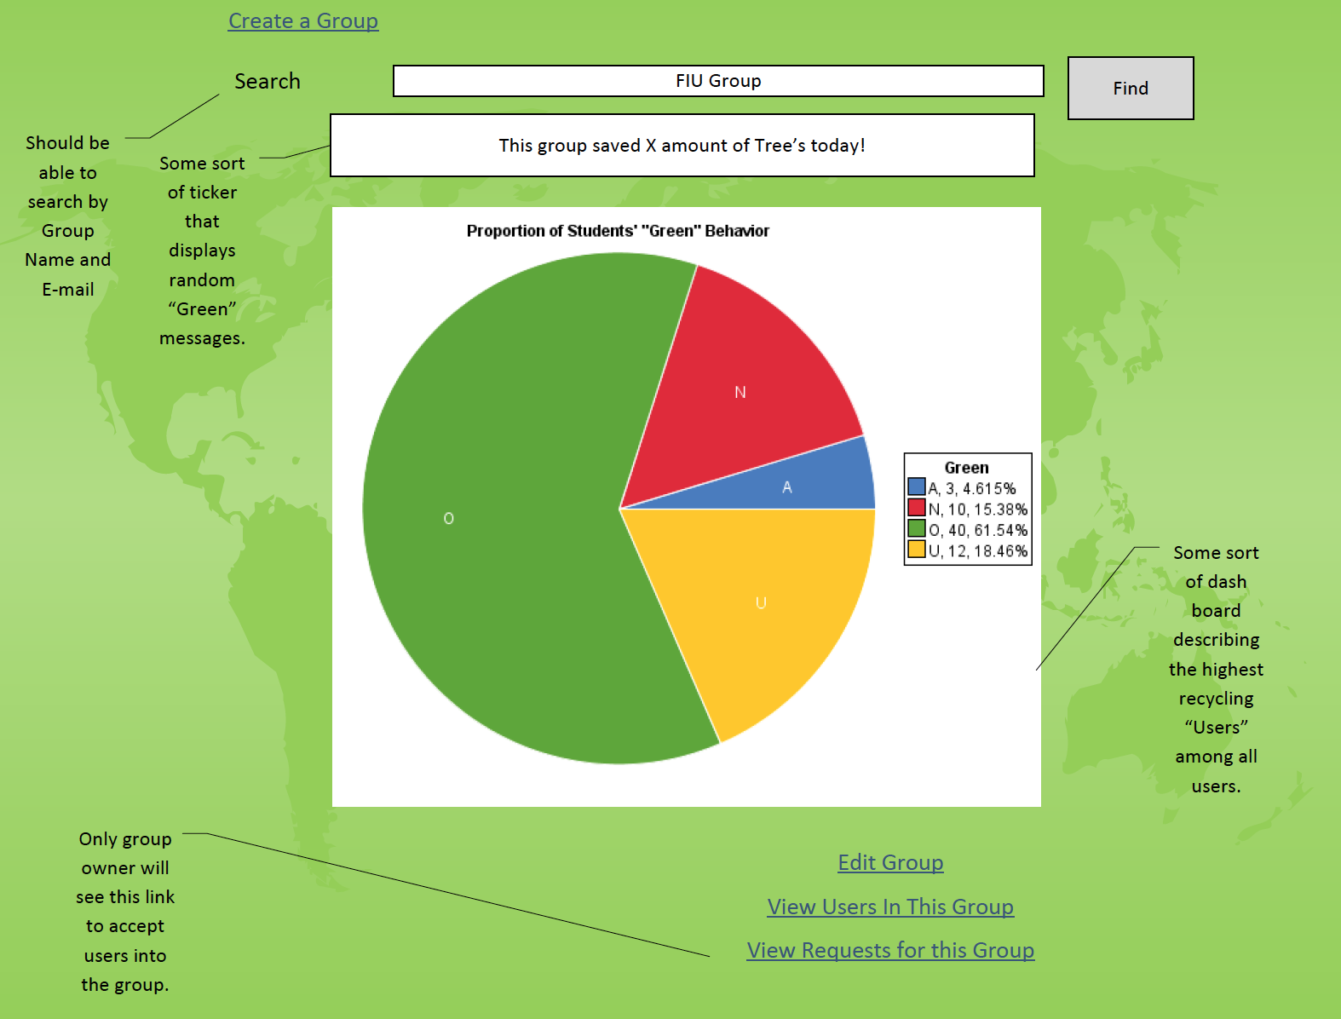

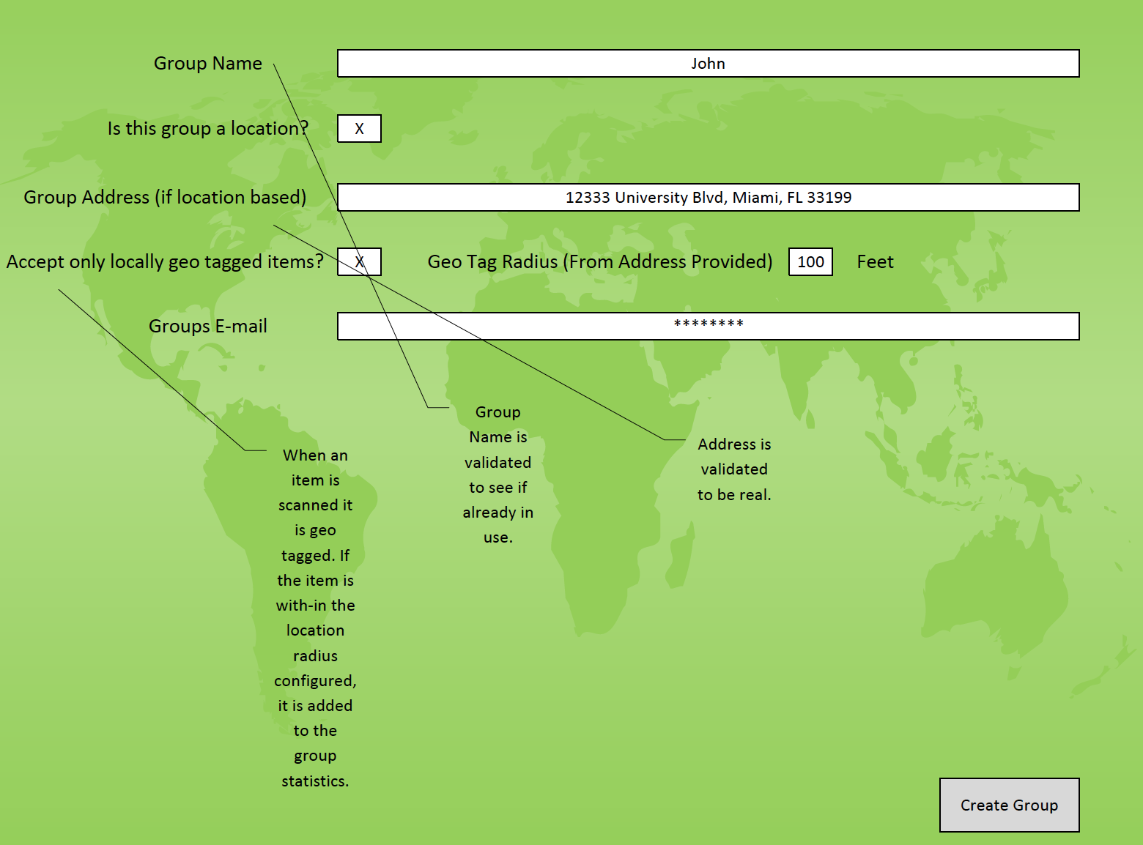

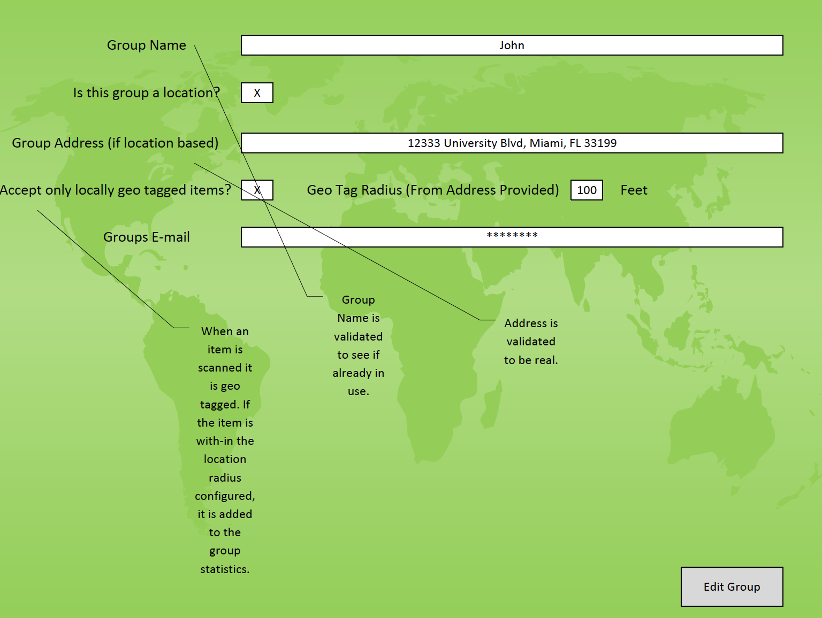

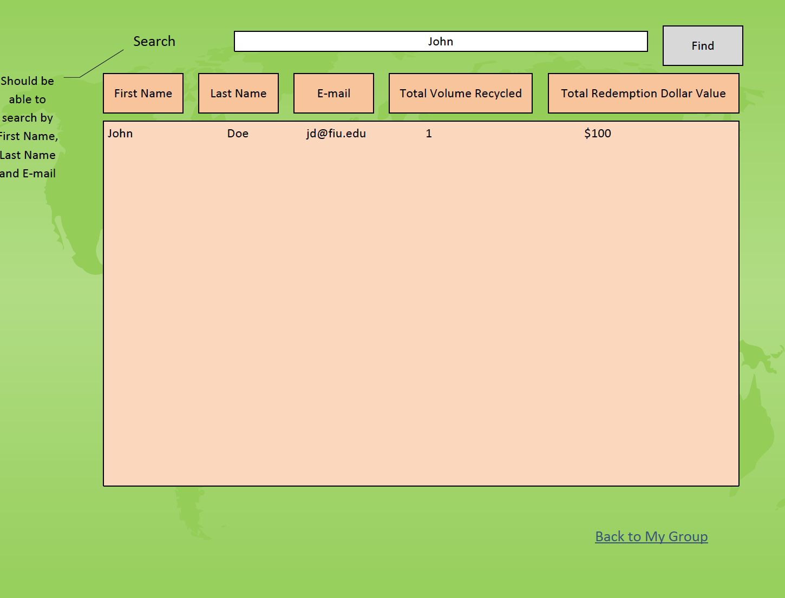

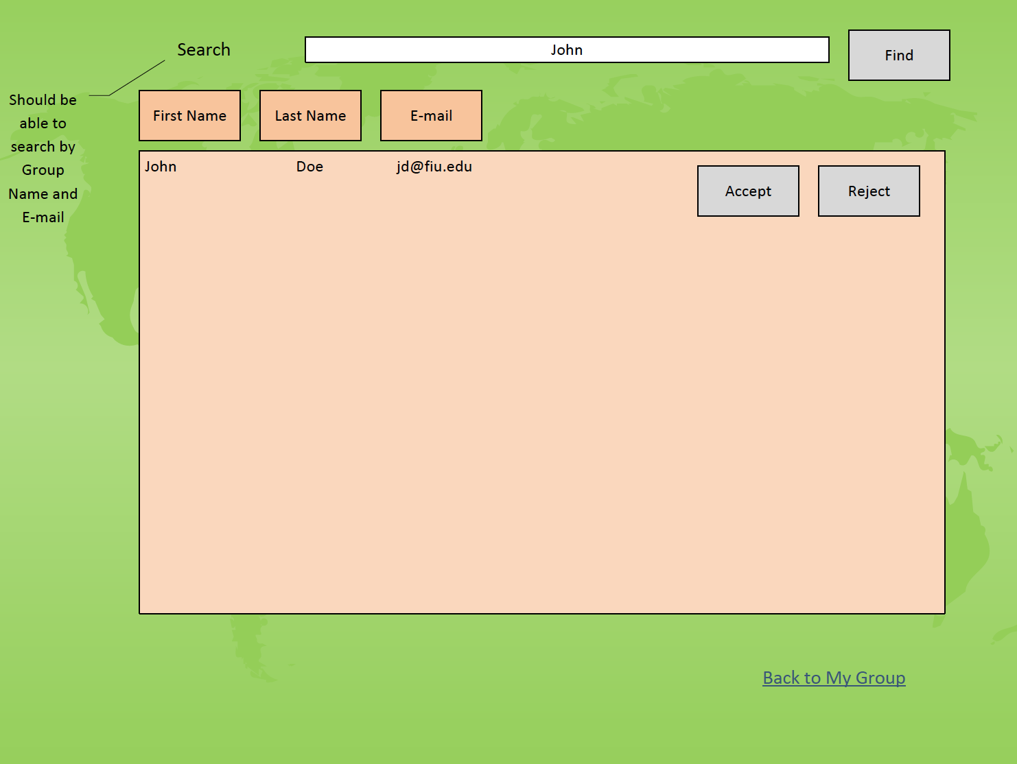

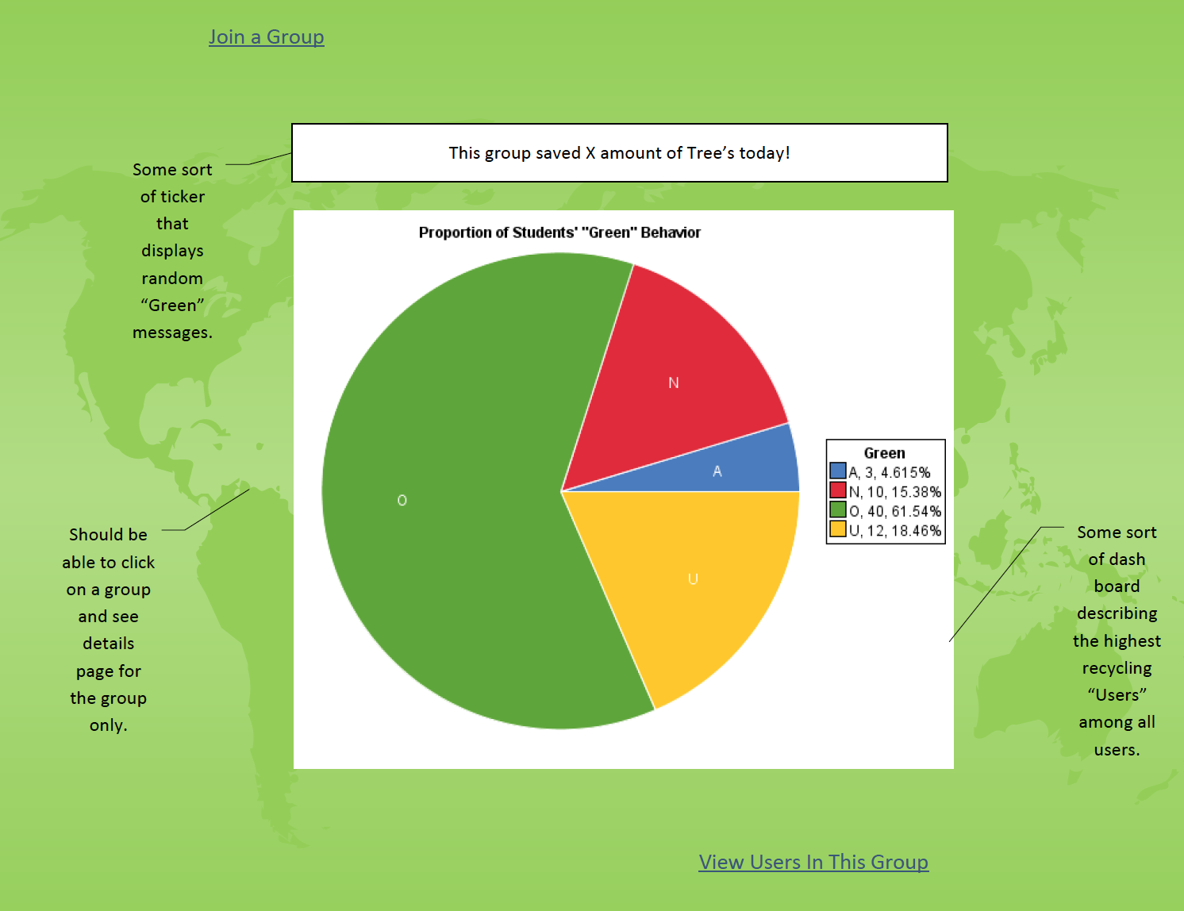

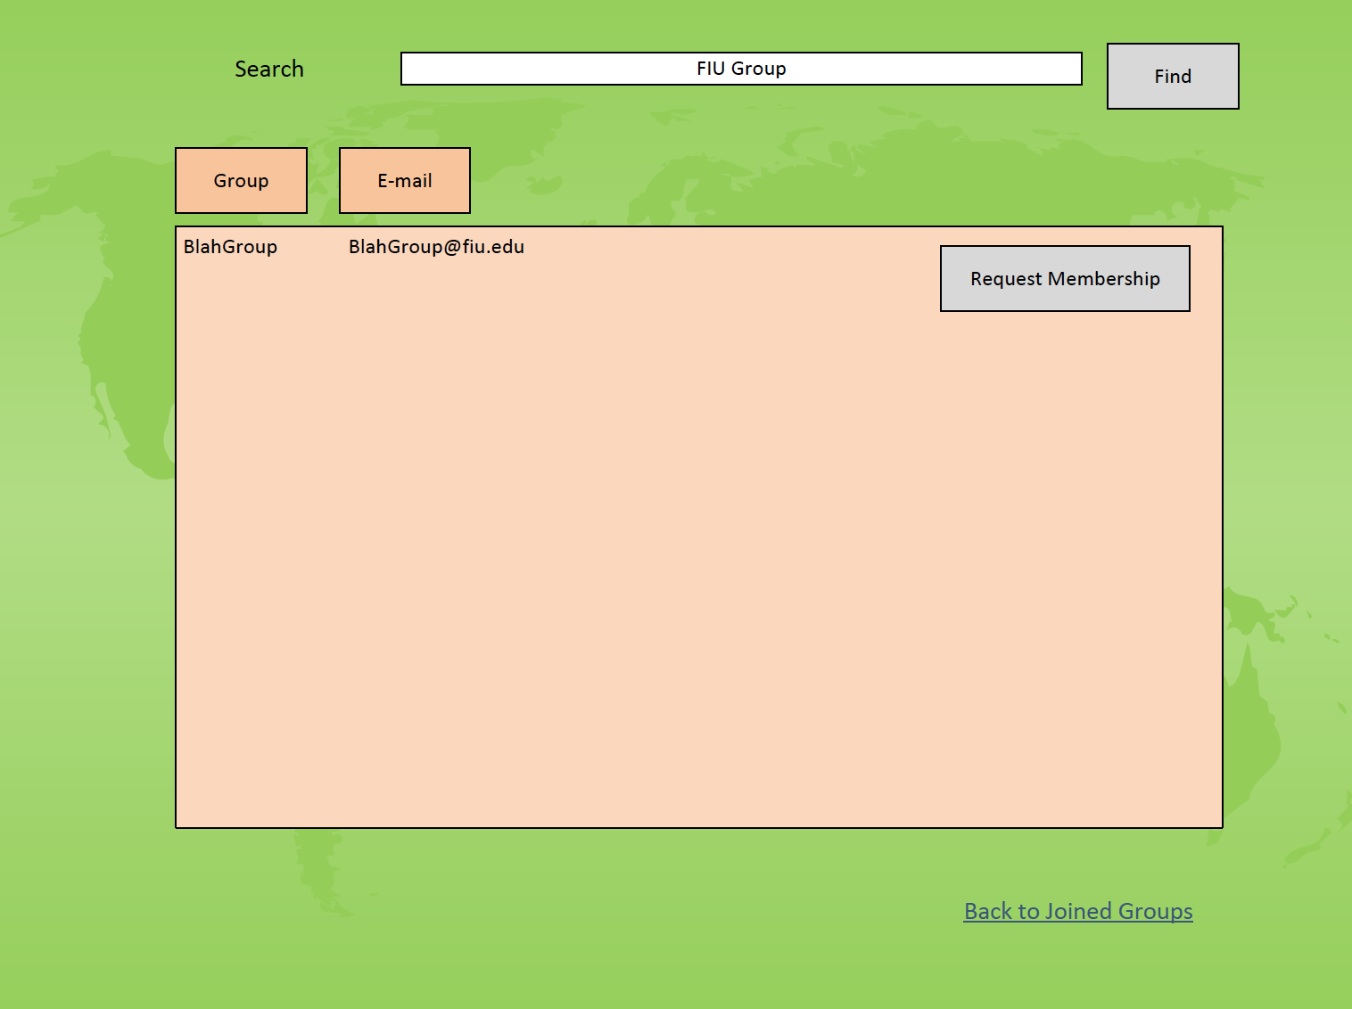

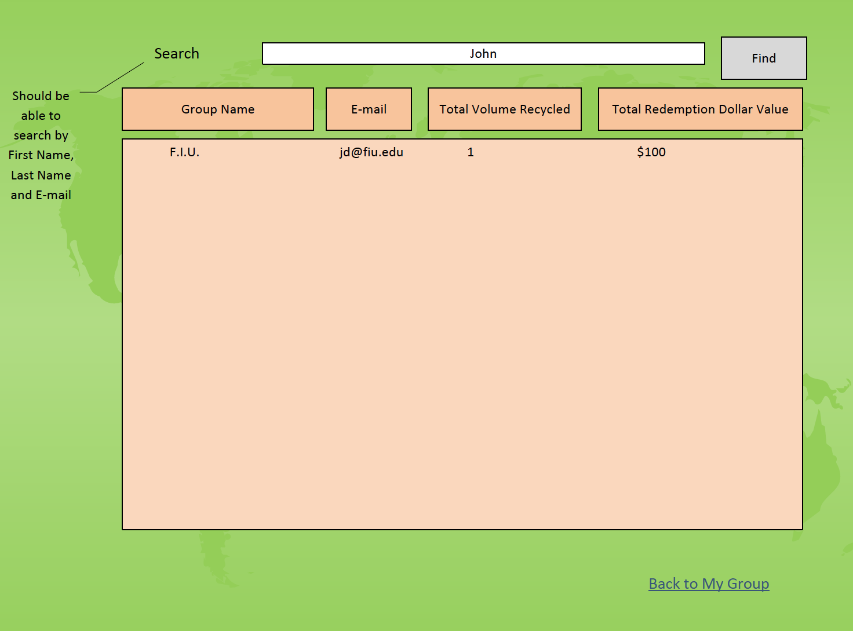

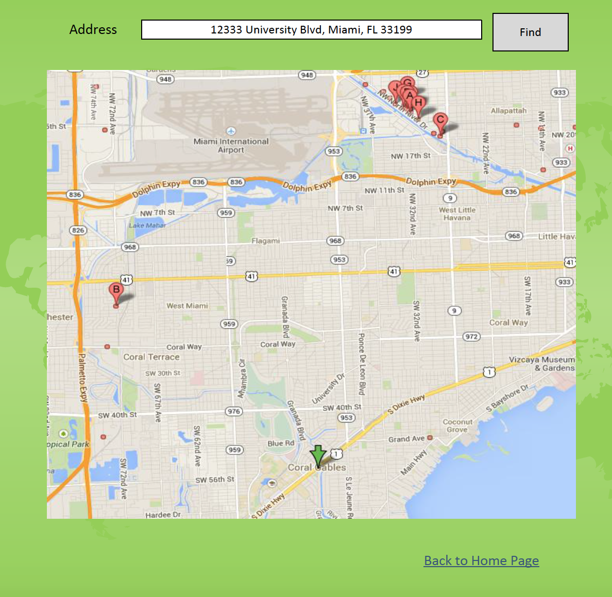

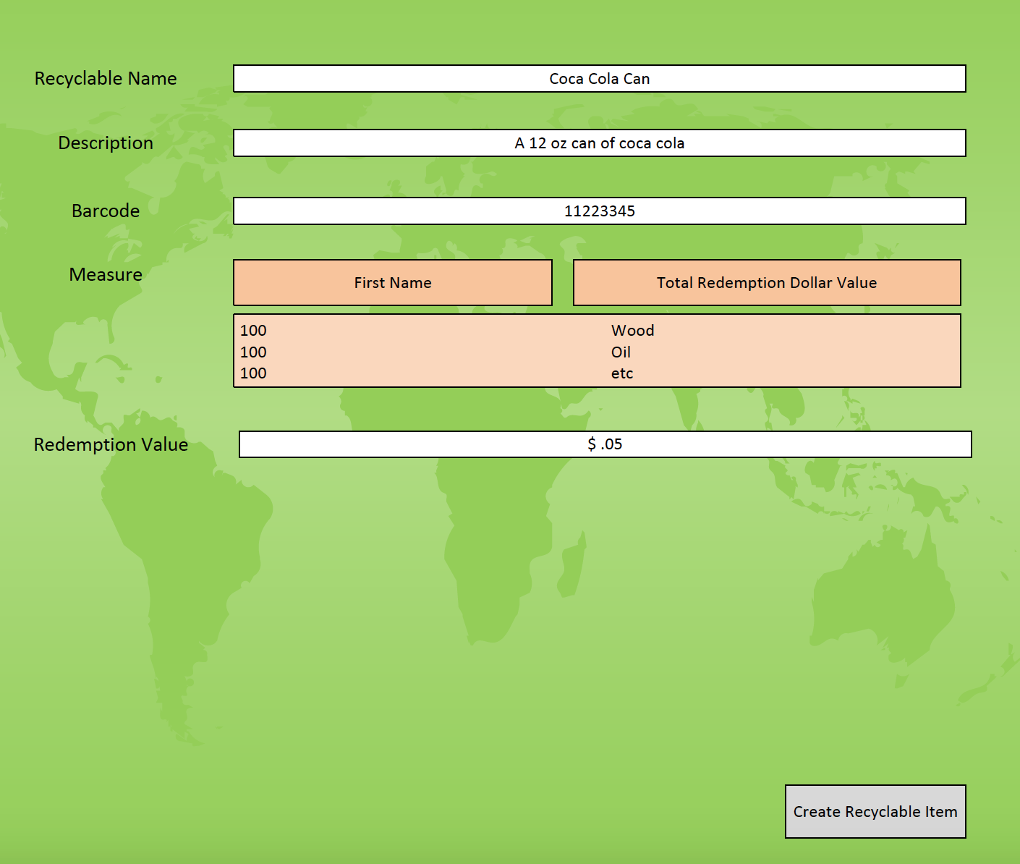

## Appendix F - Diary of meeting and tasks.

**Meeting 09/08**  
  
Attendants: Monica del Prado, Jorge McGarry  
  
-Created website template  
  
-Agreed on initial main features:  
User administration: create, delete, change account  
User authentication  
Framework for reporting dashboard  
Group Administration by group's owners  
Group administrator's approval for new user request  
Recyclable items' administration  
Group promotion administration  
Savings ticker  
Site administration: eco saver ticker, web admin, items admin, user admin, group admin  
Detailed data page for recycled items  
Assign redemption value to recycled items  
Scan items to validate recycling action  
GPS Location with every scan  
Recycling locations' administration

Work assigned:  
Monica will work on user scenarios  
Jorge will work on website

**Meeting Minutes 9/14:**  
Attendants: Monica del Prado, Jorge McGarry  
  
Refined Website Mock up and overall design of system.  
Added a scenario to Create Recyclable Item.  
Discussed what a Recyclable Item should include. It was decided Recyclable items should be only be items that have barcodes. It was decided that the Recyclable item was suggested by users and accepted by a Site Administrator.  
Discuss adding a team aspect to the system.  
Discussed how My Groups versus Joined Groups worked.  
Discussed what Recycling locations was going to show. It was decided it would show Recycling Centers, and Location Recyclable Groups.  
Decided that a Recycled item can only be associate to one location at a time.  
Work assigned:  
Monica will finish feasibility and start working on requirement document  
Jorge will finish mobile app mockup and set up test environment

**Meeting minutes 9/15**

Attendants: Monica del Prado, Jorge McGarry

We ordered our Trello cards appropriately. They were a bit randomly assigned up to this point, so we finalized a format.

We started cross training and learning IBM worklight, working on a Hello World Project tutorial from the IBM site.

We spoke to Mr. Caraballo about our steps going forward. He recommended we do a story board with the mock ups and scenarios we have on our Feasbility document.

Work assigned,

Monica will work on the first Half the user scenario's for the Story Board.

Monica will work on completing the Hello World Project tutorial for the IBM site.

Monica will start creating the Web Page templates.

**Meeting Minutes 09/17**  
  
Attendants: Monica del Prado, Jorge McGarry, Juan Caraballo  
  
New approaches for the application:  
-More flexibility on validation aspect of the application (accepting to log items without barcodes)  
-Taking a picture of an item without could get you points as well  
-Educate people about what you recycled  
-Encourage people by providing information such as "on this program today, 5 other people did that" or "last week 100 other people did that"  
-Analysis of recycled items in terms of resources they consume or save (today because you throw this away you save this much energy and its 3 less power plants they want to build)  
  
Storyboard:  
-Elaborate more on storyboards so we can show the general flow of the application  
  
Next steps:  
-Try to schedule meeting to discuss feedback  
-Monday meeting at FIU with IBM team  
-FPL meeting will be schedule for next week (probably Wednesday)

**Meeting Minutes 9/18**

Attendants: Monica del Prado, Jorge McGarry,

We meet at starbucks.

We got Eclipse and IBM worklight installed in both are systems.

Going through the Hello World project on the ibm worklight tutorial site, we couldn't get certain things to work. The Worklight development server was causing us huge headaches as on Monica's system it failed to start and on mine as well. We finally got it working perfectly and completed the hello world tutorial (among other tutorials we have been going through).

We then installed MySQL and got the database connectivity between ibm worklight and MySQL working.

Work assigned:

Monica will work on doing more tutorials from the ibm worklight website

Monica will start coding the edit profile page.

# References

***None***